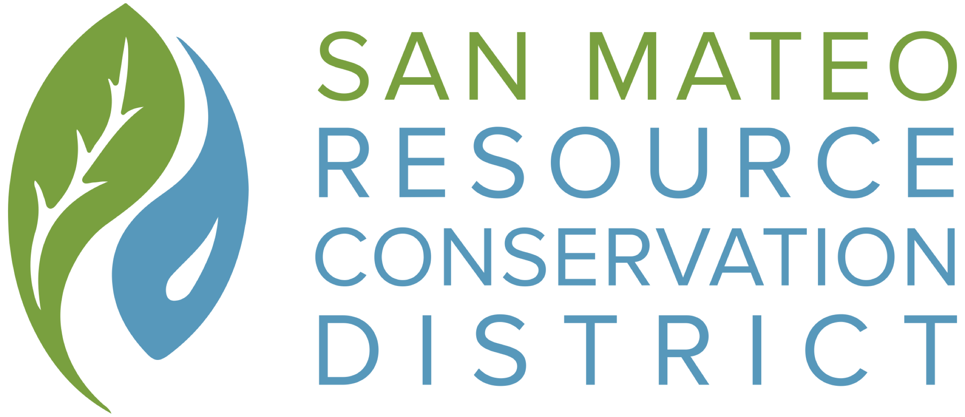

-Public Draft-

San Mateo County Forest Health and Fire Resilience
Public Works Plan (PWP)

Project Proponent: San Mateo Resource Conservation District

Date of Public Review Draft PWP: May 6, 2021
Date of Proposed RCD Public Hearing: June 17, 2021

Introduction

This Public Works Plan (PWP) has been designed in collaboration with staff from the California Coastal Commission (CCC), County of San Mateo Planning Department, CalFire, and California State Parks. This PWP is based on in the requirements of Section 30605 of the Public Resources Code, which enables the CCC to “promote greater efficiency for the planning of any public works or state university or college or private university development projects and as an alternative to project-by-project review.” PWPs are meant to provide a single document that establishes a framework for comprehensive planning, reviewing, and permitting. This then allows a suite of related activities that would otherwise trigger the need for individual Coastal Development Permits (CDPs) to instead be analyzed as an integrated and coordinated system, thus expediting the permitting process and saving money through use of a comprehensive permit vehicle. This PWP has also been developed to function as a companion to CalFire’s statewide Vegetation Treatment Program (CalVTP) and its associated Programmatic Environmental Impact Report (PEIR). In addition to the CalVTP, the collaborators developed the Coastal Vegetation Treatment Standards (Coastal VTS) to provide additional guidance and clarity for projects to be implemented within the Coastal Zone and within and/or in proximity to Environmentally Sensitive Habitat Areas (ESHAs). As such, this PWP provides a planning framework to review and authorize individual vegetation management projects in San Mateo County over the next ten years using principles, strategies, and best management practices that align fire prevention planning with coastal resource protection.

The San Mateo Resource Conservation District’s (RCD’s) proposed Forest Health and Fire Resilience PWP focuses explicitly on developing a cost-effective and programmatic approach to compliance with the California Coastal Act to increase the pace and scale of critical project implementation to improve both ecological conditions and the resilience of our landscapes to future climate change-induced wildfire. Projects that fit within, and are consistent with, the PWP and are designed with RCD oversight will be able to utilize the compliance procedures articulated in this document and will not be required to obtain individual CDPs from the County or pay them CDP fees.

This PWP is intended to serve as an optional compliance pathway for Forest Health and Fire Prevention projects within San Mateo County’s Local Coastal Program (LCP) area. Local landowners will continue to be able to obtain a traditional CDP through the County if they so choose or if a project cannot be designed to meet the standards and guidance provided in this PWP. Projects on federal land or with a federal lead agency can continue to comply with the Coastal Zone Management Act through the CCC’s Federal Consistency Office in San Francisco, and projects that are currently exempt from the Coastal Act will continue to be exempt.

This PWP is divided into the following 7 Sections:
- Section I: Introduction
- Section II: Purpose and Need
- Section III: Program Description
- Section IV: CalVTP Protection Measures and the Coastal VTS
- Section V: Local Planning Context
- Section VI: Summary of CalVTP Project Specific Analysis for Camp Butano Creek
- Section VII: Administration, Approval Process & Program Review
- Section VIII: Glossary of Terms

Purpose and Need

Purpose
The 2020 California wildfire season was a record-setting year of wildfires that burned across the state of California. “As of the end of the year, nearly 10,000 fires had burned over 4.2 million acres, more than 4% of the state’s roughly 100 million acres of land, making 2020 the largest wildfire season recorded in California’s modern history. California’s August Complex fire has been described as the first “gigafire” as the area burned exceeded 1 million acres. The fire crossed seven counties and has been described as being larger than the state of Rhode Island.” The 2020 wildfire season arrived on the heels of the 2018 wildfire season, which at the time was the largest and most destructive on record. The mass destruction seen in the 2018 wildfire season ushered in a series of executive orders, legislation, and reports focused on identifying (a) the factors driving the level of catastrophic fire affecting the state, (b) the barriers to implementing fuel load reduction and forest resilience work at an appropriate pace and scale, and (c) the key tools and mechanisms necessary to turn the tide on this crisis and set the state on a trajectory that reduces the risk, severity, and impact of catastrophic wildfires. The California Forest Management Task Force’s January 2021 Wildfire and Forest Resilience Action Plan is a clear call for increasing the pace and scale of fuel reduction and forest health actions, and places the essential work described in this PWP within the critical context of state, regional, and local fire resilience efforts.

Like many areas of the state, forest, woodland, and grassland landscapes across the Santa Cruz Mountains are undergoing significant change. The climate here is becoming warmer and drier, endemic species are at risk, invasive species are on the move, and sudden oak death has taken an immeasurable toll on regional ecosystems and overall forest health. At the same time, drier site-adapted conifer species are displacing hardwoods and other sensitive plant species, reducing biodiversity and affecting the suitability of these habitats for rare and special-status wildlife. Altered fire regimes and increased fuel loads are driving larger and more catastrophic wildfires. The result has been damaging changes to ecosystems that require environmentally sensitive landscape-level treatments to redirect the path of both changing climates and ecological conditions impacting the Santa Cruz Mountains and surrounding communities. The 2020 CZU Lighting Complex Fire is a stark example of the level of risk, wildfire severity, and impacts to our human and biological communities in this landscape. The CZU burned 86,509 acres in San Mateo and Santa Cruz Counties, destroyed 1490 buildings, and exhibited extreme fire behavior. Initial estimates suggest that over 50% of the impacted area burned at high fire severities. Many forested stands that were topographically exposed to the extreme fire behavior experienced significant tree mortality and habitat losses that will take decades to recover.

In addition to the direct human and ecological toll of these catastrophic wildfires is the global toll of their greenhouse gas emissions. The California Air Resources Board, in their draft December 2020 report titled, Greenhouse Gas Emissions of Contemporary Wildfire, Prescribed Fire, and Forest Management Activities, estimates that California’s 2020 wildfire season resulted in the release of approximately 112 million metric tons of carbon dioxide into the atmosphere. This is equivalent to approximately 24.2 million passenger vehicles driven for an entire year .

In the wake of the 2020 CZU fire, partners across the Santa Cruz Mountains are redoubling their efforts to design, permit, and implement critical, high-priority vegetation treatment activities that will reduce future risk of catastrophic, severe intensity fires and create a mosaic of climate and fire resilient native ecosystems. The San Mateo and Santa Cruz County RCDs, in partnership with CalFire, the Coastal Conservancy, public and private landowners, technical advisors, and the Coastal Commission will be leading a regional prioritization effort to identify, design, permit, and implement multiple mission-critical forest health and fuel load reduction projects within the Coastal Zone over the proposed ten-year timeframe of this PWP. This effort will use CalFire Fire Hazard Severity Zone (FHSZ) maps, new high resolution vegetation maps, and input from public and private sector experts in ecosystem and wildfire science to create an ongoing docket of high-priority projects for implementation. Both RCDs currently have funding through grants from CalFire, the Coastal Conservancy, and others for planning and implementation of multiple forest health and fire resilience projects within the Coastal Zone. The RCDs expect additional public and private grant funding over the next decade for design, permitting, and implementation of these priority projects due to the high fire risk within the region, and especially within the Coastal Zone.

This PWP provides a planning framework to review and authorize individual vegetation management projects in San Mateo County’s Coastal Zone over the next ten years using principles, strategies, and best management practices that align fire prevention planning with the protection of coastal resources. Over the proposed ten-year period of the PWP, the RCD plans to conduct high-priority forest health and fire resilience projects with voluntary collaborating landowners within the PWP Program Area in moderate to very high wildfire hazard areas of the Coastal Zone of San Mateo County. However, activities will not occur across the entirety of this region. The RCD of Santa Cruz County is developing a companion PWP for a program area that spans from the border with San Mateo County in the north to outskirts of Santa Cruz in the south.

Need
The coast is particularly vulnerable to catastrophic wildfires due to historic development and resource management patterns. High-priority forest health and fire prevention projects must be carried out on a routine basis to promote fire resiliency in these coastal areas. Efficient implementation requires programmatic streamlining of California Environmental Quality Act (CEQA) compliance and Coastal Act authorizations. The California Board of Forestry created a tool to address CEQA compliance for large and complex fuel management and forest health projects through adoption of the PEIR the CalVTP in January of 2020 (https://bof.fire.ca.gov/projects-and-programs/calvtp/calvtp-implementation/ ). This proposed PWP, along with the Santa Cruz County companion PWP, will be the first of their kind: a programmatic counterpart to the CalVTP to enable streamlined compliance with the California Coastal Act.

To reduce risk of catastrophic wildfire and improve the ecological conditions and trajectories of our forests, woodlands, and grasslands, this PWP provides a programmatic authorization tool that utilizes the CalVTP along with targeted strategies for projects within the coastal zone (as directly incorporated into this PWP and articulated in the Coastal VTS) as the critical framework for project analysis. This PWP enables the San Mateo RCD and project partners to design and implement multiple mission-critical forest health, ecosystem restoration, and fire resilience projects throughout the PWP Program Area over a ten-year period. This PWP also creates a clear and agreed upon process for approval of individual projects submitted under the PWP (Section VI) that includes:

- early consultation among Commission staff, RCD staff, registered foresters or qualified professionals, CalFire, and local landowners;
- inclusion of the Coastal VTS developed by Coastal Commission and RCD staff and technical advisors into the CalVTP Project Specific Analyses (PSAs);
- timelines for PSA review and approval under the PWP process, including through the preparation of Notices of Impending Developments (NOIDs);
- a process for projects that are of the same type and meet the same goals and standards as articulated in the CalVTP and Coastal VTS, but do not fit under the VTP due to either their location being outside the Treatable Landscape or their scale being too small to warrant use of the extensive CalVTP PEIR process; and
- a process for monitoring, enforcement, and programmatic review.

This effort leverages significant collaboration between Coastal Commission staff and RCDs over the past 15 months to develop a set of agreed-upon vegetation treatment standards that are referred to as the Coastal VTS (Exhibit A). The Coastal VTS, coupled with the CalVTP PEIR, provides clear guidance on special requirements for Forest Health and Fire Prevention projects within the Coastal Zone. This effort may also serve as a successful pilot that can be exported to other coastal communities or even coastwide to address the nexus of Forest Health and Fire Prevention projects and Coastal Act compliance.

Program Description

Overarching Goal of Forest Health and Fire Resilience Program

This PWP, and the projects that will be approved under it, directly support the intent of the San Mateo RCD’s Forest Health and Wildfire Resilience Program goals, California's climate goals, the goals of the 2021 California Wildfire and Forest Resilience Action Plan, and the goals of the CCC and applicable Local Coastal Programs for the protection of ESHAs. Approved projects are likely to be implemented within or adjacent to ESHAs and will be designed to do the following.

Proactively restore forest health, improve ecosystem resiliency, and conserve working forests by conducting ecologically minded forest health treatments.

Protect state water supply sources by strategically implementing ecological restoration projects across priority watersheds.

Encourage the long-term storage of carbon in forest and woodland trees and soils through the reduction of dense understory, thus promoting larger, healthier stands of mature trees.

Minimize the loss of forest carbon from large, intense wildfires through reducing ladder fuels and brush resulting from years of fire suppression.

Promote public safety, health, and welfare and protect public and private property through the implementation of ecologically restorative fuel reduction treatments in the wildland-urban interface.

Project Design Approach

Vegetation communities and their associated faunal assemblages have evolved with specific disturbance regimes. These regimes result in a mosaic of habitats, and along with energy inputs and stability over time, are important drivers of diversity. In Mediterranean climates, such as those found in much of California, fire is the most important, large-scale natural disturbance regime driving the distribution and composition of vegetative communities.

An expanding population, increased development into the wildland-urban interface, and current policy, which concentrates the state’s resources on fire suppression, has resulted in significantly altered vegetation communities and increased fire risk to lives and property. These facts have been widely recognized and significant resources are now being directed towards fuels treatments and forest management. While these treatments are largely motivated by an increase in catastrophic wildfire, they present an opportunity to provide ecological benefits on the lands where they are implemented and to the broader landscape that they are designed to protect.

When developing forestry and other vegetation management projects, the terms forest health, ecosystem restoration, and fuel reduction are often used interchangeably; however, they can either refer to markedly different treatments or end states, or ideally to very similar ones. In the broadest sense, a healthy forest or ecosystem is one that possesses the ability to sustain the unique species composition and processes that exist within it. This encompasses a system’s biodiversity, including the plant, animal, and fungal assemblages that occur there, as well as the ecosystem processes and services that the forest provides, such as carbon sequestration, erosion control, and nutrient cycling. Managing for ecosystem restoration or health means managing to sustain and support these assemblages and processes.

Fuel reduction, while often supporting forest or other ecosystem health, is focused on the type, arrangement, and quantity of flammable materials found in the landscape. By modifying any of the attributes mentioned above, fuel reduction projects seek to alter fire behavior, typically reducing intensity, rate of spread, or flame length to assist in wildfires or prescribed fire control. The ultimate goal is to design and implement fuel reduction projects that help protect life and property from wildfire, while simultaneously furthering forest health and ecosystem benefit goals.

Considerate, knowledge-driven fuel reduction projects seek to emulate the effects of evolutionary fire regimes, create a system that is equipped to respond to natural disturbance events in the future, or provide strategic safety measures for fire personnel and the general public, with minimum impacts to the natural environment. With vegetation serving as the primary source of fuel in wildland fires, manipulation of vegetation to create fire resistant, ecologically resilient, and healthy ecosystems is paramount to ensuring the safety of human life and property as well.

As such, while forest health projects are explicitly designed to directly improve both ecosystem health and the provisioning of other essential ecosystem services, fuel reduction projects should, when practicable, also be designed to directly improve ecosystem conditions (e.g., removal of exotic invasive plant species, management that mimics natural disturbance regime, creation of additional edge habitat, etc.). Fuel reduction projects that cannot be designed to directly improve or restore ecosystems or ecosystem processes will provide indirect ecosystem benefits by reducing the intensity, rate of spread, and extent of catastrophic wildfire on adjacent habitats and ecosystems.

If appropriately designed and implemented, forest health and fuel reduction projects should achieve as many of the following goals as feasible:

promote a mosaic of native vegetation types that support diverse native floral, faunal, and fungal assemblages and are resilient to climate change;

improve habitat for rare, threatened, and endangered plant and animal species where they are present;

increase the ability to manage wildfire and implement prescribed fire;

reduce impacts to natural and cultural resources from fire suppression activities;

maintain important cultural landscapes;

significantly reduce loss of life and property from catastrophic wildfire; and

educate the public about the role of fire in California’s landscapes and their role in it.

These goals acknowledge that complete re-establishment of fire regimes that existed during the evolutionary history of the plants and animals found within the Santa Cruz Mountains cannot be replicated under current conditions. It is also accepted that even if historic fire regimes were re-established, these natural communities have been so altered that the effects of these regimes would not restore most of these communities to a pre-contact state.

Given these constraints, where possible, evolutionarily appropriate fire regimes or surrogates (e.g., mechanical, manual, herbivory, etc.) for those regimes should be enacted or maintained. The following literature provides peer-reviewed support for the design approach described in this PWP: Keeley 2002 , Stephens et al. 2012 , and Vaillant et al. 2009 .

To accomplish this vision of ecological restoration and resilience, improved forest health, and reduced wildfire risk and severity, this PWP will guide development, approval, and implementation of high-priority forest health and fire prevention projects within the PWP Program Area of San Mateo County’s Coastal Zone over the next ten years. The PWP Program Area depicts the eligible area where activities under the PWP could occur. However, activities will not occur across the entirety of this region.

Program Area
The San Mateo RCD’s Forest Health and Fire Resilience PWP covers an area within the County’s LCP jurisdiction that stretches from boundary with Santa Cruz County in the south to the outskirts of the City of Pacifica in the north. The Santa Cruz County RCD is developing a companion PWP to provide similar coverage there. The PWP Program Area encompasses nearly 85,000 acres where potential future project activities could take place. The RCD does not expect PWP activities to be implemented across the entirety of the Program Area, but at various locations and properties within it. Map #1 shows the geographic context within which the PWP fits as well as the relationship between the PWP Program Area and the approved LCPs for cities within San Mateo County. The PWP Program Area does not include any lands within approved LCPs other than the County of San Mateo LCP.

Map #2 displays the PWP Program Area overlayed on CalFire’s Fire Severity Zone Maps to provide context for future planning efforts within the PWP Program Area. Map #3 shows the CalVTP Treatable Landscapes map and how that program and its associated PEIR overlap with the PWP Program Area. While the PWP has been developed as a companion to the CalVTP, it is expected that some high-priority projects outside of the modeled treatable landscape will be developed and authorized through the PWP. Map #4 provides additional context by illustrating the vegetation types within the PWP Program Area.

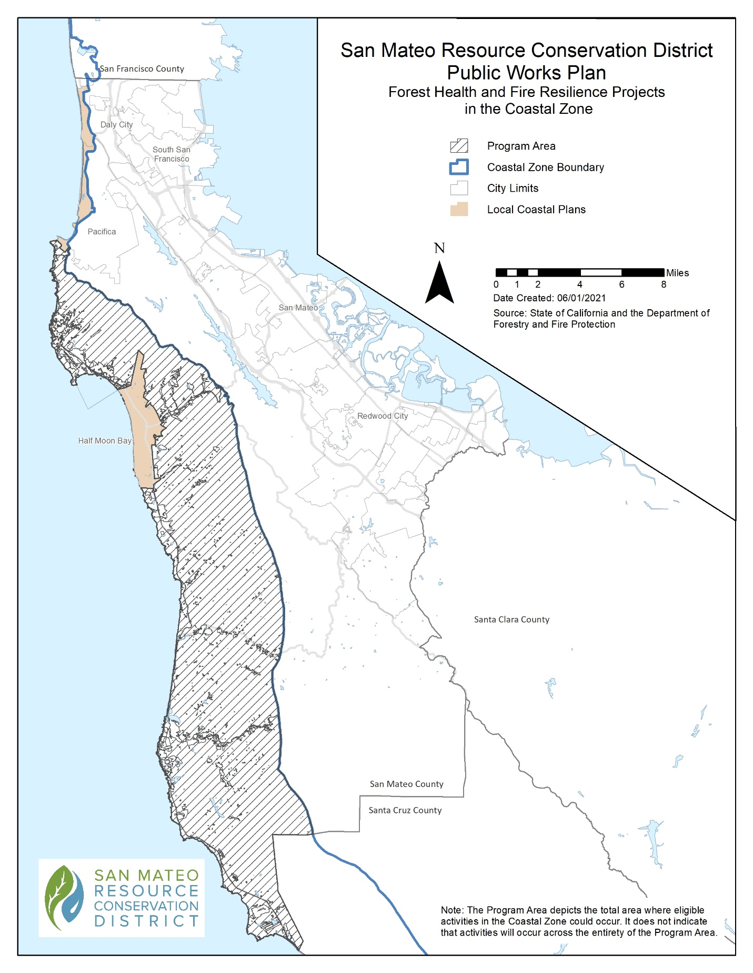 Map 1: PWP Program Area and LCPs

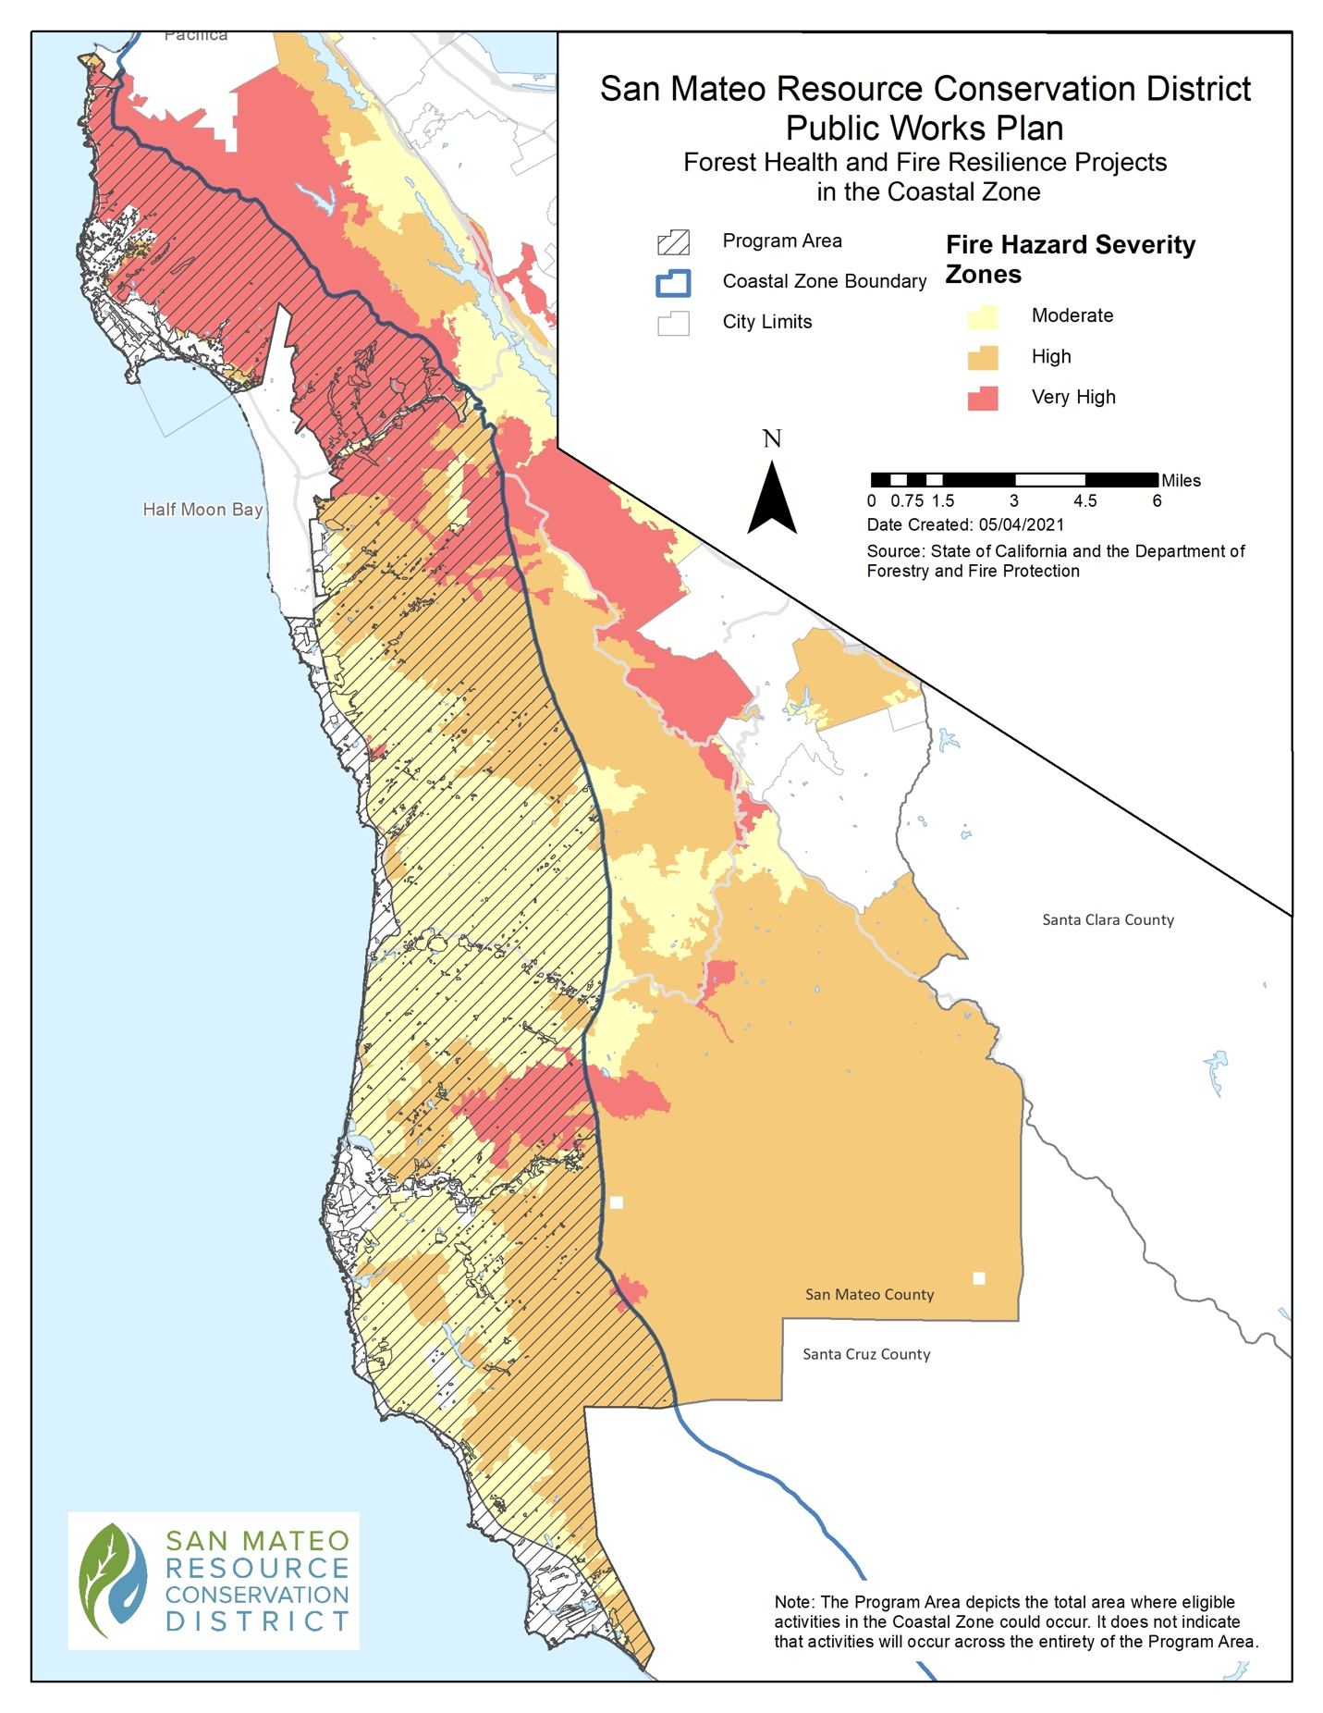
Map 2: PWP Program Area with Calfire Wildfire Severity Hazard Map

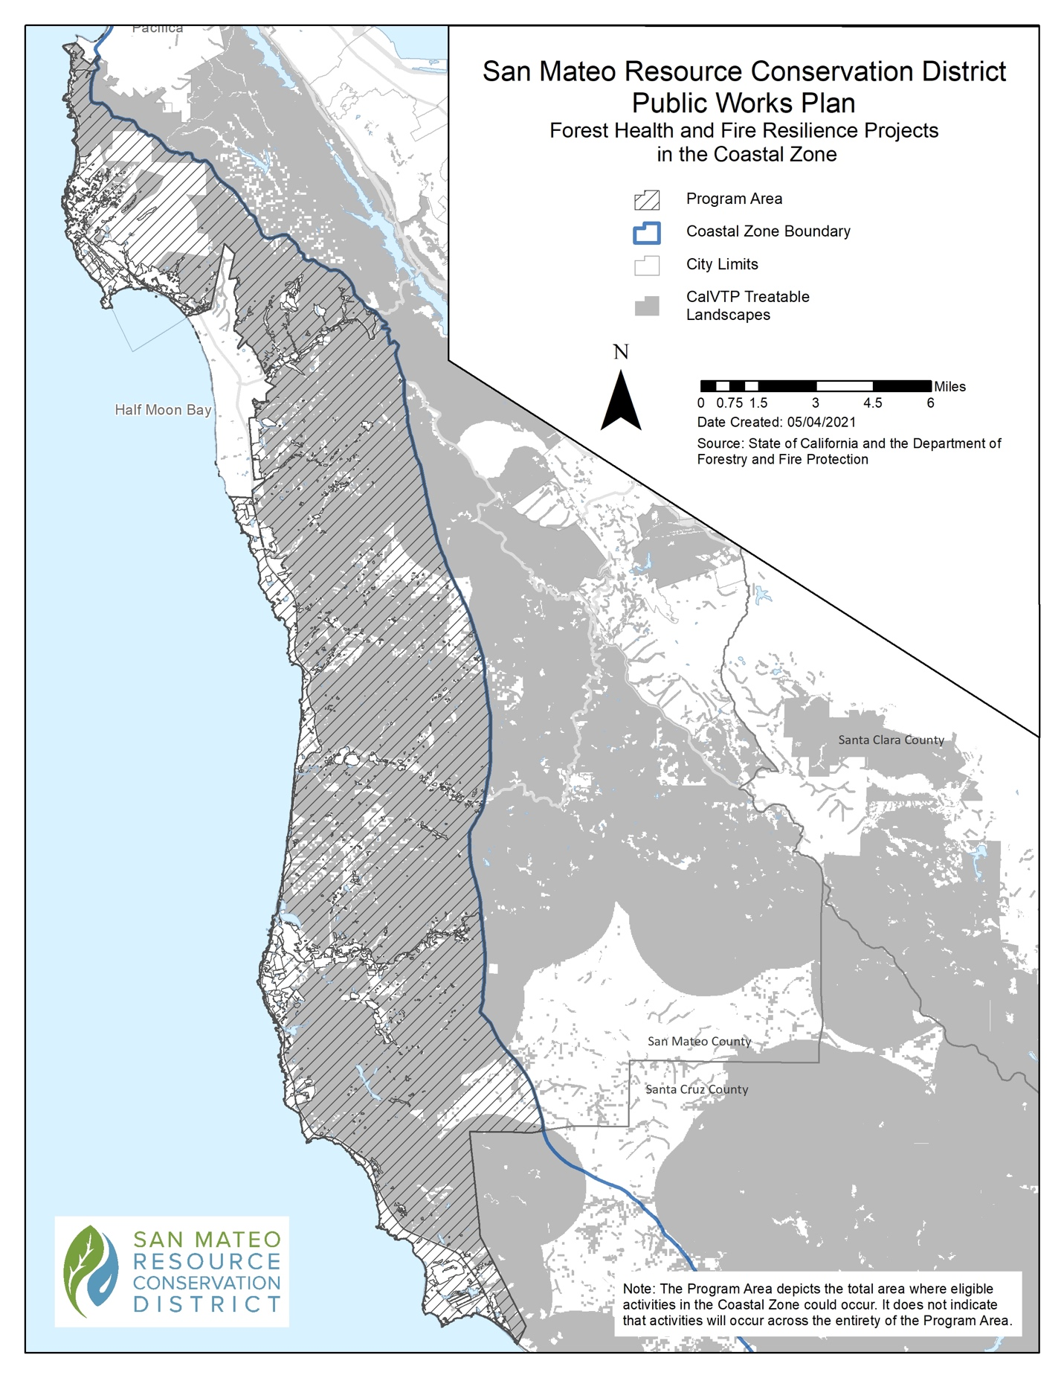
Map 3: PWP Program Area with CalVTP Treatable Landscapes

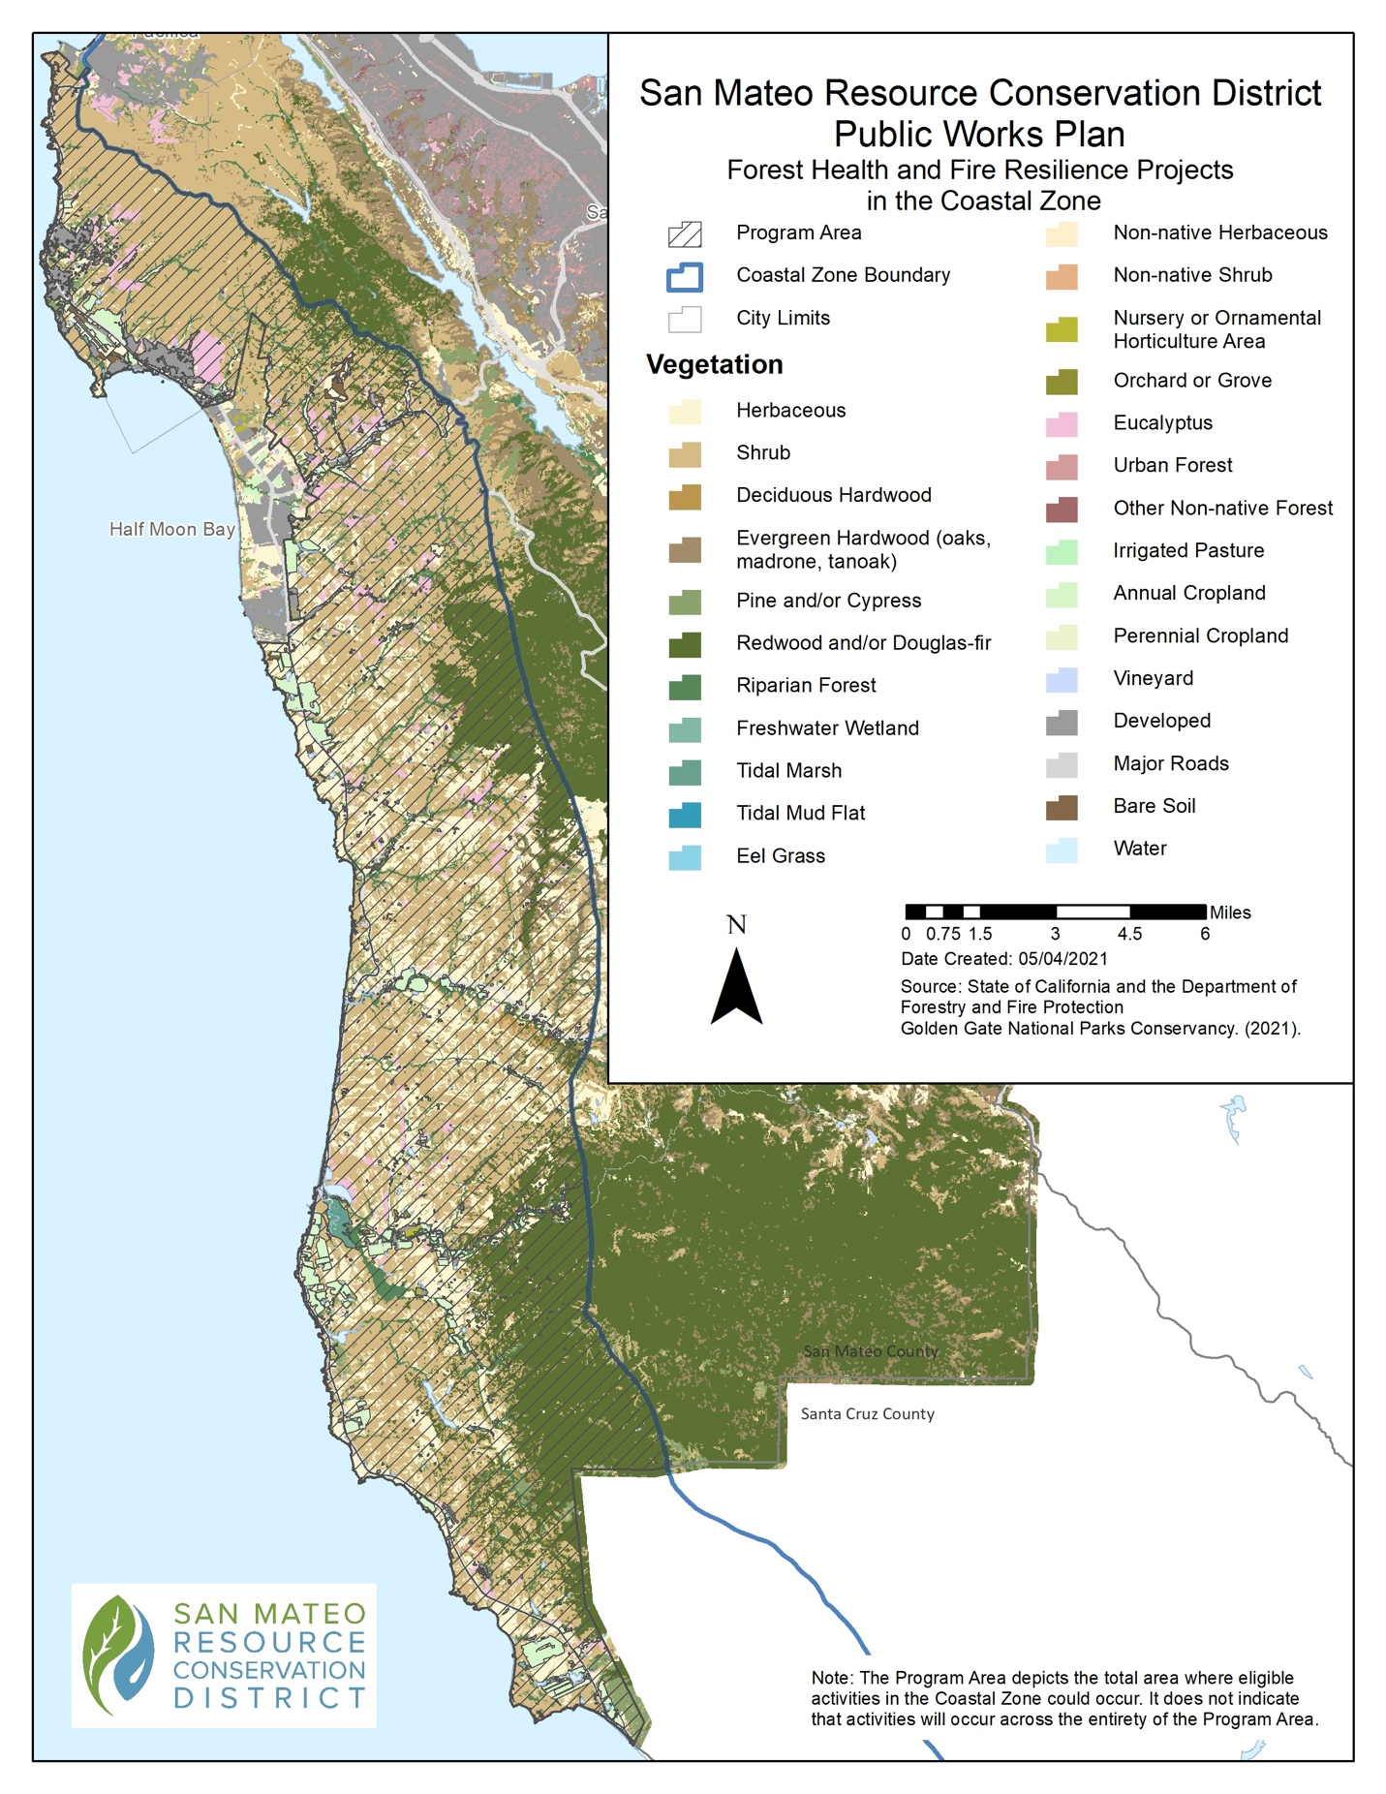
Map 4: PWP Program Area with Vegetation Types

Types of Projects and Activities to be Covered

The projects covered under this PWP will utilize the CalVTP for planning guidance, environmental review, and analysis and will adhere to the mitigation and monitoring requirements as provided in that program. In addition, projects will be designed explicitly to meet the coastal zone-specific requirements contained in the Coastal VTS and designed collaboratively with Commission staff (Exhibit A). Projects occurring within the Coastal Zone, but outside of the CalVTP Treatable Landscape, and/or projects that are too small in scope to warrant utilizing the extensive CalVTP PEIR, will be developed to meet the requirements of the CalVTP as well as the requirements of the Coastal VTS in order to be approved under the PWP. CEQA compliance for projects outside of the CalVTP Treatable Landscape or for projects that are too small in scope to use the CalVTP PEIR will be accomplished through separate, appropriate environmental review—most likely a Categorical Exemption or a Mitigated Negative Declaration that tiers off the analyses and measures in the CalVTP PEIR.

All PWP activities will follow the definitions, guidance, and measures provided in the CalVTP PEIR. The CalVTP PEIR divides project activities into three categories based on the goals of each activity. These categories include Ecological Restoration, Wildland-Urban Interface (WUI) Fuel Reduction, and Fuel Breaks. It is important to note that while the CalVTP PEIR distinguishes between Ecological Restoration and both WUI Fuel Reduction and Fuel Breaks, for the purpose of this PWP, WUI Fuel Reduction and Fuel Break activities will be designed, when practicable, to provide direct ecosystem benefits. Direct ecosystem benefits that could accrue from WUI Fuel Reduction or Fuel Break projects include: removal of non-native invasive vegetation, creation of ecologically valuable edge habitat, revegetation with native plant species, and modifications to vegetation structure that mimic the effects of natural disturbance regimes, etc. Based on geography, proximity to critical infrastructure, and/or specific fire prevention goals, integration of direct ecological restoration benefits may not be possible for all WUI and Fuel Break treatments. That said, all WUI and Fuel Break treatments will provide meaningful indirect ecosystem benefits through reduced severity, intensity, likelihood and extent of catastrophic wildfire in forest, woodland, shrubland, and grassland habitats.

The Coastal VTS categorizes potential projects into two project types that differ from the three defined in the CalVTP PEIR. These two categories are Forest Health projects and Fire Prevention projects. Forest Health projects provide ecological benefits and improve the habitat’s fire resiliency, including within ESHAs. Fire Prevention projects, while designed to protect ecosystems as much as feasible, include a level of vegetation removal that may adversely impact ESHAs in order to assure protection of existing structures or infrastructure. Pursuant to this PWP, Forest Health projects can include projects that are categorized through the CalVTP as Ecological Restoration, Wildland-Urban Interface (WUI), and in some cases, Fuel Break activities (for shaded fuel breaks). Fire Prevention projects include CalVTP WUI Fuel Reduction and Fuel Break activities that could have adverse impacts on ESHAs but are designed to reduce the likelihood of significant and long-term impacts from catastrophic wildfire. These terms are defined below, are consistent with the definitions in the CalVTP, and have been cross-walked with the terms used in the Coastal VTS.

Ecological Restoration:
This treatment includes all of the projects referred to as Forest Health projects as well as other ecosystem health projects in woodlands, shrublands, and grasslands. In areas that have departed from the natural fire regime as a result of fire exclusion, ecological restoration would focus on restoring ecosystem processes, conditions, and resiliency by moderating uncharacteristic wildland fuel conditions to reflect historic vegetative composition, structure, and habitat value. These activities will result in increased forest and ecosystem health, improved native species composition and age structure, and mitigated tree encroachment into coastal shrub and grassland ecosystems. It also includes removing weedy and invasive species and diseased vegetation, with an emphasis on moderating uncharacteristic fuel build-up due to the deprivation of natural fire regimes. This project type generally includes the Forest Health Coastal VTS projects. A given project could include multiple treatment types and fit under either Forest Health or Fire Prevention or both, depending on the specific situation and project objectives that can be implemented.

WUI Fuel Reduction:

Located in WUI-designated areas, fuel reduction would generally consist of strategic vegetation removal to prevent or slow the spread of non-wind-driven wildfire between structures and wildlands. WUI fuel reduction includes vegetation thinning, removing ladder fuels, and increasing defensible space. WUI Fuel Reduction projects can be designed to protect adjacent habitats and ESHAs from extreme fire conditions. In some cases, WUI Fuel Reduction projects can also be designed to provide ecological benefits and improve the habitat’s fire resiliency within the treatment area. WUI Fuel Reduction projects are described in the Coastal VTS under both Fire Prevention and Forest Health. A given project could fit under either Fire Prevention or Forest Health or both, depending on the specific situation and project objectives that can be implemented.

Fire Prevention/Fuel Breaks:

In strategic locations, fuel breaks remove flammable vegetation to slow wildfire spread, create a staging area for firefighting efforts, and provide ingress and egress during a wildfire incident. Fuel breaks result in zones of significantly less-dense vegetation, often in a linear layout, and often associated with an existing road or right-of-way. A shaded fuel break maintains a targeted level of tree cover while moderating surface fuels to limit a fire’s ability to spread. Fuel Break projects can be designed to protect adjacent habitats and ESHAs from extreme fire conditions. In some cases, shaded fuel breaks can also be designed to provide ecological benefits and improve the habitat’s fire resiliency within the treatment area. Fuel breaks are described in the Coastal VTS under both Fire Prevention and Forest Health. A given project could fit under either Fire Prevention or Forest Health or both, depending on the opportunities and constraints for each project location.

The CalVTP PEIR was designed to provide coverage for Ecological Restoration and Fire Break/Fuel Reduction projects located in state-designated treatable landscapes. These treatable landscapes are a combination of State (Fire) Responsibility Area (SRA) lands that fall under the three categories listed above: identified WUI areas, existing fuel breaks along ridgelines and roadways, and ecological restoration treatment areas. As per Appendix PD-1 from the CalVTP PEIR, these treatable landscapes were developed using three Geographic Information System (GIS)-based analyses that compared SRA land, treatable categories, and vegetated landscapes dominated by tree, shrub, or grass communities. Any projects located outside of SRA land (e.g., within local responsibility areas or on federally owned land), as well as areas not pre-identified using the aforementioned treatable landscape categories, are omitted from coverage by the CalVTP PEIR, but not necessarily from the PWP. Because treatable landscapes were determined for the entirety of California utilizing GIS modeling, local, site-specific conditions were often unaccounted for. Map #3 shows areas within and outside of the CalVTP treatable landscape in the PWP Program Area. The PWP envisions three scenarios where projects would be approved under the PWP, but would not or could not utilize the CalVTP for CEQA compliance. These include:

Fuel Breaks not included in the treatable landscape:
During the CZU Lighting Complex Fire, relic, poorly maintained rural fire roads, skid trails, and logging roads were utilized by fire agencies as strategic suppression locations in the Santa Cruz mountains. Roads of this type are often not included in the “treatable landscape” of the Cal VTP PEIR either because they have been decommissioned, poorly maintained, or have not followed prominent ridges. Nevertheless, these fuel breaks have provided and continue to provide strategic locations for fuel break/fuel reduction projects, and their maintenance is critical to local fire prevention and firefighting efforts.

WUI Fuel Reduction projects outside of the treatable landscape:
Critical Fuel Reduction projects may occur in residential and rural-residential settings within the Coastal Zone and outside of the SRA. Many of these areas were once dominated by low-growing coastal scrub and grassland and are now a matrix of homes and towering flammable fuels. These fuels include invasive tree species such as Eucalyptus and fast growing non-native invasive woody shrubs like hypericum, gorse, and broom. WUI Fuel Reduction projects could include the strategic removal of these species for both fuel management and ecosystem restoration. Projects could occur on private or public lands in the WUI and would include the mechanical and manual removal of non-native invasive species. This treatment might include a targeted herbicide treatment to address invasive species resprouts. Restoring these areas to low-growing native vegetation would meet the objectives of removing hazardous fire fuels in the community while restoring ecosystems and increasing biodiversity. Other projects might include thinning a Eucalyptus stand and removing ladder fuels to reduce the risk of a crown fire.

Projects that are smaller than the scale of project envisioned for the CalVTP:
While the CalVTP PEIR does not provide a minimum size limit for projects, the level of analysis for the full PEIR process is not easily scaled down for small projects (though these projects would still require CEQA and Coastal Act compliance). Under the PWP, projects in this category would still be designed and analyzed to meet the parameters of the Coastal VTS and all applicable elements of the CalVTP, but would not be approved under the PEIR. For example, a neighborhood Eucalyptus removal project along ½ acre of urban or suburban WUI land is too small to warrant inclusion under the PEIR but would prove extremely valuable in reducing flammable vegetative fuel loads in a neighborhood setting. A project like this could be designed to replace non-native vegetation with native species, and would likely require authorization under the LCP. The PWP anticipates these projects would be approved through the NOID process with creation of a project document and supporting studies that are similar to the PSA and include the relevant measures and standards from the CalVTP and Coastal VTS.

Maximum and minimum intensity of activities proposed to be undertaken
Both Forest Health and Fire Prevention project types will provide fire resiliency benefits in the coastal zone to protect against loss of life, property, and ecosystems from catastrophic wildfire. All projects under this PWP, specifically projects being conducted within ESHAs, will provide ecological benefit, either directly or indirectly, to the greatest extent feasible. In addition, Forest Health projects are explicitly designed to provide direct ecological benefits to local landscapes. Given the nature of vegetation treatment activities, it is recognized that some projects (or portions of projects) cannot be designed to fully meet forest health or ecological restoration standards while also meeting the necessary fire resiliency objectives. For Fire Prevention projects that are not able to include forest health or ecosystem restoration as a primary objective, the project (or portion of project) will be designed to minimize impacts to coastal resources, specifically ESHAs, as required in Project Standards 2 and 3 (see Section IV, below), in consideration of the necessary fire resiliency objectives. To ensure that benefits to the environment are maximized through forest health and ecological restoration planning in the PWP Program Area, the majority of the total acreage of covered projects will be Forest Health projects.

Within each of the project types described above, the CalVTP identifies five specific treatment types that a Project Proponent may utilize to implement projects and meet project goals and objectives. This PWP has been developed to be consistent with the CalVTP, and the maximum and minimum intensity of activity or activities proposed to be undertaken will comply with the analysis, evaluations, and limitations approved as part of the PEIR for the California Vegetation Treatment Program (CalVTP) in January of 2020 (https://bof.fire.ca.gov/projects-and-programs/calvtp/calvtp-implementation/) except that projects under the PWP may be proposed outside of the geographic area covered by the PEIR. In addition to the CalVTP, all projects undertaken through this PWP will adhere to the Coastal VTS for projects in the Coastal Zone (Exhibit A) and all other Project Standards in Section IV of this Plan. These standards were developed through extensive collaboration between the RCD, local stakeholders, CalFire and Coastal Commission staff.

Minimum and maximum intensity of a given treatment will be based on the project goals and objectives as well as the size and location of a given project. Projects approved under this PWP may include one or many different treatment types and intensities. The five CalVTP treatment types that are proposed for use in projects covered under this PWP include the following:

Prescribed burning:
The application of low-intensity fire onto target vegetation for purposes of ecological restoration and fuel reduction, including pile burning and broadcast burning. Prescribed burns are carried out with appropriate preparation, such as creating a fire line by removing fuels that will prevent the fire’s spread outside of the target area. They are planned and conducted in close coordination with fire personnel and carried out only when weather, air quality, and fuel conditions are optimal. Prescribed burning includes applying fire to coastal prairie to reduce thatch (fuels) and restore native vegetation, and to a low intensity forest understory burn aimed at reducing ground fuels, fire intolerant species, and control the occurrence and spread of sudden oak death.

Mechanical Treatment:
This treatment type focuses on the use of motorized equipment to cut, uproot, crush/compact, or chop existing vegetation. Among a variety of uses, the most common and efficient manner is to utilize this equipment on slopes less than 50% to increase the health and vigor of the forest by reducing competition among vegetation. This type of treatment will also utilize excavators to reach from existing roads, thus reducing competing vegetation adjacent to these roads.

Manual treatment:
This treatment focuses on the use of hand tools and hand-held power tools such as shovels, chainsaws, weedwhackers, or loppers to remove target vegetation. A crew limbing trees and removing ground fuels with chainsaws and loppers to create a shaded fuel break is a common form of manual treatment.

Prescribed herbivory:
This treatment utilizes domestic livestock such as goats, cattle, or sheep to reduce height and density of vegetation. Goats are often deployed to reduce the density and height of brush species, woodlands, and forests with dense understory growth or managed cattle grazing to keep grasslands, oak woodlands, and coastal prairie habitats healthy and less prone to catastrophic or severe fire behavior.

Herbicide application:
Herbicides are applied through ground application methods and used to target specific invasive species when other methods are not feasible due to their costs, effectiveness, or potential environmental impacts. Some applications are applied to new foliar growth of invasive species where uprooting may cause excessive soil disturbance. Other applications target the stumps immediately after the felling of invasive species, such as Eucalyptus globulus, to prevent resprouting.

Maximum size of facilities proposed to be constructed pursuant to the PWP and the proposed timetable and any phasing of development activity contemplated.

No new facilities are proposed for construction as part of this PWP.

The RCD will work with local landowners, CalFire, technical advisors, and Coastal Commission staff to prioritize and develop projects that will be implemented over the ten-year period of this PWP. This process is planned through the Regional Prioritization Effort, which is currently underway and led by the RCDs of San Mateo and Santa Cruz Counties together with CalFire and the Coastal Region Prioritization Group. Potential PWP Projects will be phased over the course of the ten-year term and approved through NOIDs that will be submitted to the Commission for approval. NOIDs may include anywhere from one to many projects and NOIDs are expected to be submitted to the Commission between one and three times per year. If implementation of a specific activity/project is delayed due to unforeseen circumstances, the approved project will be automatically put into the queue for implementation the following year.

Projects/activities approved under the PWP will include both an initial implementation phase and subsequent follow-up management at ecologically appropriate intervals. These expected intervals will be clearly spelled out in each PSA submitted as part of the NOID process.

PSAs shall be submitted to the CCC as part of the NOID process for review and approval for the purpose of coastal development authorization prior to conducting projects. Coordination between the project proponent and CCC shall occur as early as feasible in the design process to streamline consistency review under the PWP (see Section VI, for more on administrative processes related to the PWP).

PSAs shall include clear problem and goal statements (e.g., overall project goals, fire prevention goals, ecological goals, etc.) associated with each project proposed pursuant to this PWP and will be submitted as part of the NOID process. These statements are intended to assist project proponents and CCC in developing mutual understanding of the potential impacts and benefits—both short and long term—for each project, and the structure for the problem and goal statements are articulated in the Coastal VTS. It is expected that this information will be incorporated into Standard Project Requirements (SPRs) BIO – 3 (Sensitive Natural Communities) and SPR – BIO – 8 (Identify and Minimize Impacts to Coastal Zone ESHA) of the CalVTP project PSA including the completed VTS document provided in the attachments section of each project PSA.

CalVTP Protective Measures and Coastal VTS

PWP Project Requirements
Please refer to the CalVTP PEIR Program-Level SPRs and Mitigation Monitoring and Reporting Program (MMRP) tables for a full accounting of relevant protective measures that will be implemented for all projects under this PWP. The SPRs can be found in Appendix PD-3 of the CalVTP Final PEIR at (https://bof.fire.ca.gov/projects-and-programs/calvtp-homepage/calvtp-program-eir/) and the MMRP is located in Appendix B of the Final PEIR, Volume I at (https://bof.fire.ca.gov/projects-and-programs/calvtp-homepage/how-to-use-the-calvtp/). Exhibit B provides a summary of SPRs that are expected to be commonly applied to PWP projects. Due to the fact that most, if not all, projects approved under this PWP will take place in or near ESHAs, project specific PSAs will also provide detailed information that addresses items in the Coastal VTS provided in Exhibit A:
- Protect Ecosystem
- Vegetation Removal Hierarchy
- Limit Equipment Types
- Limit Herbicide Use
- Prescribed Herbivory Use
- Control Invasive Species
- Limit Fencing
- Accelerants
- Soil Stabilization
- Protect Coastal Public Access and Recreation

PWP Project Standards

Project Standard 1. Qualifying PWP Projects
Projects subject to this PWP shall be limited to Forest Health and Fire Prevention projects, as those terms are defined in the Coastal VTS and undertaken within the PWP Project Area (Map #1, above) over the next ten years from the date of PWP certification.

Project Standard 2. Consistency with the CalVTP PEIR:
PWP projects shall be fully consistent with the requirements of the CalVTP PEIR, including the SPRs and mitigation measures of the CalVTP PEIR, except where more specifically addressed in Project Standard 3. These CalVTP PEIR measures include, but are not limited to:

- Administrative Standard Project Requirements, SPRs AD-1 through AD-9
- Aesthetic and Visual Resource Standard Project Requirements, SPRs AES-1 through AES-3 and Mitigation Measure AES-3
- Air Quality Standard Project Requirements, SPRs AQ-1 through AQ-6 and Mitigation Measure AQ-1
- Archaeological, Historical, and Tribal Cultural Resources Standard Project Requirements SPRs CUL-1 through CUL-8 and Mitigation Measure CUL-2
- Biological Resources Standard Project Requirements, including Special Status Plants, ESHAs, Invasive species, & Wildlife SPRs BIO-1 through BIO-12 and Mitigation Measures BIO-1a, BIO-1b, BIO-1c, BIO-2a, BIO-2b, BIO-2c, BIO 2d, BIO-2e, BIO-2f, BIO-2g, BIO-3a, BIO-3b, BIO-3c, BIO-4, & BIO-5
- Geology, Soils, and Mineral Resource Standard Project Requirements, SPRs GEO-1 through GEO-8
- Greenhouse Gas Emissions Standard Project Requirements, SPR GHG-1 and Mitigation Measure GHG-2
- Hazardous Material and Public Health and Safety Standard Project Requirements, SPRs HAZ-1 through HAZ-9 and Mitigation Measure HAZ-3
- Hydrology and Water Quality Standard Project Requirements, SPRs HYD-1 through HYD-6
- Noise Standard Project Requirements, SPRs NOI-1 through NOI-6
- Recreation Standard Project Requirements, SPR REC-1
- Transportation Standard Project Requirements, SPR TRAN-1
- Public Services and Utilities Standard Project Requirements, SPR UTIL-1
A summary of key SPRs from the CalVTP are attached to this PWP as Exhibit B.

Project Standard 3: Coastal VTS
Projects shall be fully consistent with the Coastal VTS attached as Exhibit A.

Project Standard 4: Project and Program Monitoring
Monitoring for each PWP project shall occur consistent with all specified CalVTP monitoring requirements. In addition, five years following certification of this PWP, the San Mateo RCD shall prepare a five-year programmatic review identifying at a minimum: the status of individual Projects implemented under the PWP, as well as Projects expected to be implemented under the PWP; level of program completion (e.g., number of acres treated, high-priority areas for the subsequent five years, collective monitoring results, constraints and lessons learned, and program success). The programmatic review shall be submitted to the Coastal Commission and San Mateo County. At the ten year mark following certification of the PWP, a final programmatic review shall be prepared by the RCD and submitted to the County and the Coastal Commission for review.

Local Planning Context

The San Mateo County Board of Supervisors and the California Coastal Commission approved the San Mateo County Local Coastal Program (LCP) in 1981. In June of 2013, the County Planning Department published the most recent update to the LCP that includes all of the approved amendments through 2012 as well as the Mid County Land-Use Plan Area. The RCD has reviewed this document and The San Mateo County Planning Department collaborated in development of this PWP. The PWP has been designed to meet the requirements of the LCP. As such, future Forest Health and Fire Resilience projects within the Coastal Zone and approved under this PWP, are not expected to require additional approvals from the San Mateo County Planning Department. This PWP does not currently include treatment activities within the Half Moon Bay or Pacific LCP areas.

Summary of Girl Scouts of Northern California Camp Butano Creek PSA

Forested landscapes and ecosystems are undergoing significant change as the climate warms, forest health declines as a result of sudden oak death, and altered fire regimes and increased fuel loads lead to more catastrophic wildfires. The Girl Scouts of Northern California Camp Butano Creek is one specific project that will be implemented under this PWP and that is intended to be an integral component of the PWP, pursuant to 14 Cal. Code Regs Section 13358. The full PSA for this project will be provided with the locally-adopted PWP that will be submitted to the Coastal Commission for certification in the summer of 2021.

The Camp Butano Creek property is comprised of forests dominated by predominately second growth coastal redwood, Douglas-fir, and mixed hardwood forests. The redwood forest still holds ecologically resilient characteristics from the past with scattered old growth trees and remnants of a time when the understory was more diverse. The lack of fire, until recently, and a reduced large scale stewardship effort of this property in the last 30 years, coupled with changing climates has left the majority of the property severely over stocked in the understory and mid-range tree diameters. The property experienced a low to moderate severity burn during the 2020 CZU Lightning Complex, which killed much of the understory but did not fully consume vegetative fuels, leaving an overstocked dead and dried understory with a component of regenerated vegetation.

Project treatments will include mechanical mastication and manual treatments to treat understory vegetation, dead or downed material, hazard trees, dead, dying, and diseased trees, and live trees up to 8 inches diameter at breast height (DBH) over approximately 44 acres of forestland (Map 5). The project treatment areas are predominately located in proximity to critical camp infrastructure and areas of declined forest health resulting from sudden oak death, invasive species, and the CZU Lightning Complex. Mechanical treatment areas are predominately located along ridges on slopes less than 40% with a component of reducing vegetative fuels along existing road infrastructure.

The implementation of the proposed treatments will result in a modification of the existing fuels that will ultimately support native vegetative species regeneration and restore habitat conditions including, but not limited to habitat quality and natural fire processes. Specifically, the ecologically restoration outcomes expected to be realized for the redwood forest at Camp Butano include: increased sunlight through the canopy to release a more vigorous and diverse understory; forest structure reduced approximately 300 – 400 stems per acre to approximately 200 stems per acre allowing mid-range and larger diameters redwood trees to extend their heights and expand their crowns becoming more vigorous to resist vegetation pattern transformations in the face of a climate change and increase the separation of ladder fuels from tree crowns ultimately reducing the severity of wildfire.

In addition, fuel reductions in the WUI will directly benefit communities and assets at risk, serving as emergency access points along or near evacuation routes for the nearby communities and as an opportunity to slow or stop wildfires. Habitat quality will be enhanced through WUI fuel reductions where existing habitat has been degraded due to invasive species encroachment or the accumulation of fuels. Ultimately, ecologically restorative outcomes expected from this project include the release of a healthier, more vigorous and diverse understory and more resilient residual forest stand.

The PSA for this project is being reviewed by the RCD, CalFire, San Mateo County Planning Department, and Coastal Commission staff to ensure that it both meets the criteria for inclusion under the CalVTP PEIR and this PWP.
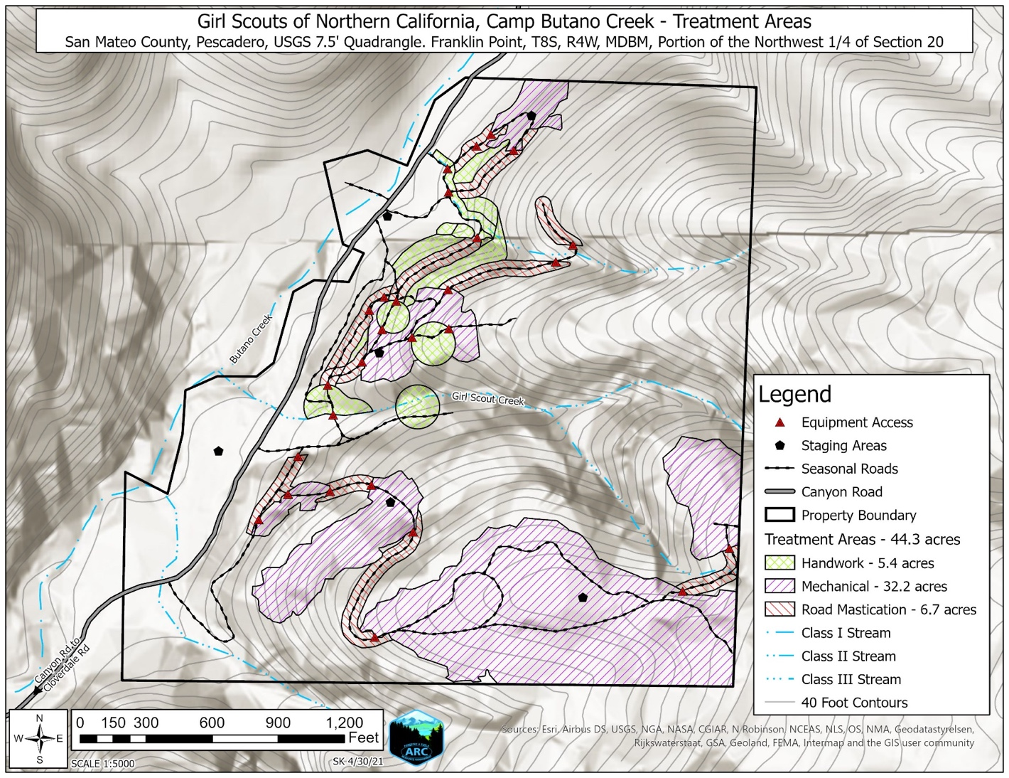
Map 5: Camp Butano Creek Project Treatment Areas Map. Map not to scale.

Administration, Approval Process & Program Review

The purpose of this chapter is to set forth procedures for reviewing and authorizing Projects contained in the San Mateo RCD’s Forest Health and Fire Resilience PWP for vegetation treatment in the coastal zone that is carried out pursuant to the Board of Forestry’s final PEIR for the CalVTP.

Roles and Responsibilities
This PWP will help expedite implementation of a series of projects in a comprehensive and coordinated manner to help meet the state’s vegetation treatment goals outlined in the CalVTP. As part of this effort, two primary actors will participate in the PWP process; their roles and responsibilities are as follows:
- The CCC shall be responsible for reviewing and acting on the PWP and any amendments to it, as well as all PWP components, including reviewing and acting on the draft and final Project-Specific Analyses submitted as part of the NOIDs, reviewing and acting on all related NOIDs, enforcing NOID (Project) conditions, and reviewing monitoring reports.
- The RCD shall be responsible for drafting the PWP and any amendments, releasing them for public review, and approving them at the local level, as well as preparing all proposed NOID (Project) components, including drafting Project-Specific Analyses, public noticing of NOIDs, submitting NOIDs to the Commission, and preparing and submitting any other Project materials to the Commission. The RCD shall, through contractual agreements with other agencies, landowners, contractors and others, initiate individual Projects in coordination with Coastal Commission and county staff and in compliance with the PWP and CalVTP PEIR. The RCD shall be responsible for monitoring of Project conditions. The RCD will partner with other agencies, landowners, contractors and others to implement the responsibilities above and shall maintain oversight to confirm that all workis consistent with the PWP and NOID processes.

Procedures for PWP Filing and Certification
A PWP is a land use planning document that plans for and sets a framework for implementing a specific public works project or array of public works-related activities. A PWP provides a land use planning alternative to LCPs for obtaining approval of large or phased public works projects, as well as any development proposed by a special district, and remains under the authority of the Coastal Commission irrespective of coastal permit jurisdictional boundaries. A PWP is an alternative to project-by-project review for public works, which would otherwise require multiple coastal development permits for different components of the public works project. A PWP must be sufficiently detailed regarding the size, kind, intensity, and location of development to allow the Coastal Commission to determine its consistency with the policies in Chapter 3 of the Coastal Act (pre-LCP certification) or the certified LCP (post-LCP certification). Once the Coastal Commission certifies a PWP, no coastal development permit is required for development that is consistent with the PWP. Instead, the Project Proponent (in this case, the RCD) provides a NOID to the Coastal Commission and other interested persons. The Coastal Commission then reviews the NOID for consistency with the approved PWP; if the Coastal Commission determines that the proposed development described in the NOID is consistent with the PWP, the development may proceed. If the proposed development is not consistent with the PWP, the Coastal Commission will apply conditions to that specific project to achieve consistency with the PWP. If the NOID describes development that is not within the scope of the PWP, the Commission will not accept the NOID for filing, and the Project Proponent will need to obtain a PWP amendment before proceeding with it.
Prior to the filing of a PWP for certification by the Coastal Commission, and pursuant to Coastal Act Section 30503 and Sections 13353.5 and 13515 of the Commission’s regulations, maximum opportunities for public participation must be afforded. A public review draft PWP must be made available to the public at least six weeks prior to local adoption of the PWP, including by posting the public draft PWP to the local government’s or RCD’s website and by transmitting it to: members of the public; each local government contiguous with the area subject to the PWP; local governments, special districts, or port or harbor districts that could be directly affected by or whose development plans should be considered in the PWP; relevant regional, state and federal agencies; and local libraries and media. Posting can be done through electronic means and does not need to be conducted via hardcopy. Further, pursuant to Section 13515(d) of the Commission’s Regulations, the RCD must provide notice of the local hearing on the public draft PWP “not less than ten (10) working days before the hearing”. The hearing should also be scheduled for a specific time and, when feasible, the hearing should be held in the coastal zone or in a place easily accessible to residents of the coastal zone.
The Public Draft of this PWP is being released on May 6, 2021 for public review and comment, which will continue throughout the Coastal Commission review and authorization process. The draft document will be distributed for public review and comment for six (6) weeks, during which time public comment is solicited.
Section 30605 of the Coastal Act allows PWPs to be submitted to the Coastal Commission for review in the same manner prescribed for the review of LCPs as set forth in Chapter 6 (commencing with Section 30500 of the Coastal Act). Sections 13371 and 13356(b)(2) of Commission’s Regulations require that the Coastal Commission not approve or adopt a PWP unless it finds that there are no feasible alternatives or feasible mitigation measures available that would substantially lessen significant adverse impact that the development may have on the environment. Section 21080.5(a) of CEQA, Section 30605 of the Coastal Act, and Section 13355 of the Commission’s Regulations also require the distribution of environmental information sufficient in detail to enable the Coastal Commission to determine the consistency of the plan with the policies of the Coastal Act or LCP, as applicable.
The Board of Forestry has prepared the CalVTP Final PEIR (November 2019) to evaluate the potential environmental impacts of the proposed CalVTP treatment activities undertaken across the state. The Coastal Commission's environmental analysis for this PWP may draw on facts from the CalVTP PEIR. However, the Coastal Commission has the authority and duty to conduct its own review of the PWP, any amendments, and any Project-specific NOIDs under the Coastal Act. Such review will also satisfy any obligations to conduct CEQA review under its certified regulatory program.
This PWP provides for a ten (10) year period in which Projects may be carried out consistent with the provisions of the PWP. The Commission may grant an extension to this timeframe through a future PWP amendment if the Commission determines that additional time is warranted and that the amendment is consistent with Coastal Act and relevant LCP requirements at that time.
In the event that the PWP needs to be amended following its certification by the Commission, Sections 13365 – 13371 of the Commission’s Regulations govern the process for such amendments. Section 13366 of the Regulations requires the RCD (or applicable local government) “to demonstrate that a public hearing at the local level has been held on the proposed amendment within a reasonable time prior to submission of the amendment application to the Commission” consistent with the standards of Section 13353.5 of the California Code of Regulations. Pursuant to Section 13367, a PWP amendment application shall be rejected if it would “lessen or avoid the intended effect, or any conditions, of a certified public works plan.” If accepted, the PWP amendment application would be noticed and scheduled for hearing as either a minor amendment (pursuant to Section 13368) and heard at the next regularly scheduled Commission hearing, or as a regular amendment (pursuant to Section 13369) and processed in accordance with Sections 13370-71. The hearing requirements for review of the PWP amendment would be the same as provided for review of a PWP, as provided in Section 13356. Any amendments will need to be found consistent with Chapter 3 or the Coastal Act or any relevant LCPs, as they exist at that time.
Lastly, after certification of the PWP, the Coastal Commission continues to retain permit jurisdiction over development on tidelands, submerged lands, and public trust lands, whether filled or unfilled, within the RCD’s service area. Under the Federal Coastal Zone Management Act, the Commission also retains federal consistency review authority over federal agency activities and federally licensed or permitted activities on or adjacent to the Project sites. Projects neither covered by the PWP nor located in the Commission’s retained permit jurisdiction shall be reviewed by the County of San Mateo for consistency with its certified LCP.

Project Review and Authorization under the PWP
Consistency determinations for individual Projects proposed as part of the PWP are made by the Coastal Commission and are subject to public review and comment and a public hearing. Sections 30605 and 30606 of the Coastal Act and Title 14, Section 13359 of the California Code of Regulations govern the Coastal Commission's review process for development proposed pursuant to a certified PWP. Section 30606 of the Coastal Act requires the public agency (e.g., Special Districts, such as an RCD) proposing the public works Project to provide a NOID to the Coastal Commission (and other interested parties, organizations, and governmental agencies), along with data demonstrating the Project is consistent with the certified PWP. Once a NOID is deemed complete, it is scheduled for a public hearing within 30 working days, at which time the Coastal Commission determines whether conditions are required to bring the Project into conformance with the approved PWP.
For the purpose of submitting a NOID for an individual Project, the RCD shall comply with the following procedures and prepare the following documents:
- Project Development: Prior to starting the Draft PSA, the RCD shall initiate discussion of a proposed Project with Coastal Commission staff by providing the Project location and scope and detailing the anticipated benefits and impacts of the Project, including expected impacts to coastal resources and potential SPRs and mitigation measures. In addition, and where required by the County LCP, the RCD shall submit to the County Planning Agency a list of all proposed projects recommended for planning and implementation during the ensuing fiscal year for review by the County.

- Site Visits: To the extent feasible, the RCD, local government(s), and relevant Commission Staff shall visit the areas proposed for vegetation treatment prior to the drafting of Project-Specific Analyses, as specified below. At a minimum, Coastal Commission staff shall provide preliminary comments on proposed Projects to identify potential issues of concern or suggest Project alternatives to explore.

- Draft Project-Specific Analysis (PSA): the RCD shall oversee the drafting of a Project-Specific Analysis for each Project as required by the CalVTP PEIR. The Draft PSA shall be completed in accordance with the requirements of the CalVTP PEIR to determine whether the Project qualifies as within the scope of the PEIR, or that the Project will not result in any new or substantially more significant impacts than as described in the PEIR or CalVTP. For Projects that fall outside the treatable landscape or for projects that are too small in scope to warrant use of the PEIR for CEQA compliance, Project Proponents will be required to develop all relevant sections of the PSA and a description of how the Project adheres to the Coastal VTS in order to be included under this PWP. All PSAs will include the following:
  - a description of the proposed Project, including a narrative description of the size, kind, intensity, and location of each proposed development and the supporting site plans and elevations thereof;
  - environmental documentation for the Project(s) including information and CEQA discretionary actions prepared pursuant to or in addition to the CalVTP PEIR, and an analysis of alternative locations for each proposed development activity, if warranted, due to significant impacts on ESHAs or other coastal resources that could be avoided or minimized by implementing in a different location;
  - all technical reports associated with the Project(s) (i.e., biological reports, geotechnical reports, traffic analyses, etc.), including all reports and plans required by the PEIR and PWP;
  - the results of consultation with parties interested in, with jurisdiction over, and/or affected by the Project(s), including consultations with concerned public entities and agencies and any additional consultation that might be required or needed;
  - all implementing mechanisms associated with the Project(s) (including but not limited to CEQA mitigation monitoring reports, legal documents, landowner authorization, etc.); and,
  - all public comments received regarding the Project(s).

- Final Project-Specific Analysis: Following review of the Draft Project-Specific Analysis by Commission staff and other interested parties, the RCD shall prepare a Final PSA for each Project as required by the CalVTP PEIR that incorporates requested revisions and includes the components required under the Draft PSA (Section iii above). The Final PSA (or relevant sections, if a project will not be utilizing the PEIR for CEQA compliance) shall be completed in accordance with the requirements of the CalVTP PEIR to determine whether the Project qualifies as within the scope of the PEIR and shall comply with the Coastal VTS.

- Preparation and Submittal of a Notice of Impending Development: Following development of the Final PSA, or in conjunction with preparation of the Final PSA, the RCD shall prepare a Notice of Impending Development (NOID) for each Project or batch of Projects for Commission review and approval consistent with the PWP. Unless there are unusual or exigent circumstances, the RCD shall give advanced written notice to the CCC Executive Director of its intent to submit a NOID prior to submitting the NOID. The RCD shall coordinate with the Executive Director to ensure that a NOID is not submitted at a time when it would be legally infeasible for the Commission to bring the item to hearing within 30 working days from being submitted and filed as complete (e.g., when the Commission is not holding a hearing in a particular month). The NOID shall adhere to and include the following procedures and materials:

  - Mailed/Emailed Notice. At least 30 working days prior to undertaking development activities, the RCD shall give written notice of its intent to implement a Project by submitting a NOID. The RCD shall send the NOID via first-class mail, e-mail, or other reasonable means, to the following persons, parties and agencies: the Coastal Commission’s Executive Director; owners of record of each property within 100 feet (excluding road rights-of-way) of the proposed Project(s); persons residing on properties located within 100 feet (excluding road rights-of-way) of the proposed Project(s), as well as those persons residing in greater distances that may need to be noticed pursuant to the CalVTP SPRs and mitigation measures; all local governments and special districts that could be affected; all regional, state, and federal agencies that may have an interest in or be affected; all other persons, parties, and agencies who have requested to receive such notice, either for the Project(s) that is the subject of the notice or for all PWP Projects; and persons, parties, and agencies that are known by the RCD to be interested in the specific Project(s) that is the subject of the notice (e.g., persons, parties, and agencies that submitted testimony or other comments during the CEQA/NEPA process for the PWP). The RCD should also post the NOID on its website in a downloadable format.

  - Notice Content. The NOID shall be clearly titled as such and shall, at a minimum, include the following information:
    - The description of the proposed Project(s), including a narrative description of the size, kind, intensity, and location of each proposed development as well as an identification of the existence of the Final PSA, including the existence of supporting materials and documentation (e.g., maps, technical documents, etc.), and information regarding where and when the NOID and supporting material is available for public review (including where the Final PSA and supporting materials and documentation can be downloaded);
    - The RCD’s approval of the Project(s), including any locally-adopted resolutions or identification numbers for filing purposes if available;
    - The anticipated date of commencement of development of the Project(s);
    - The appropriate RCD contact person(s) and her/his contact information;
    - The process for Coastal Commission review of the Project(s) (including Coastal Commission contact information and proposed Commission date of action on the NOID).

  - Posted Notice. The RCD shall post the NOID in conspicuous locations at the proposed Project(s) site(s) no later than the date that the NOID is sent pursuant to Section v.a above, (i.e., at least 30 working days prior to commencement of development activities). The Notice shall comply with the following requirements:
    - Notices that are posted shall be printed, clearly visible, and laminated or otherwise weatherproofed so as to be legible at all times.
    - Notices shall be posted at locations on the perimeter (and/or within the perimeter as appropriate) of the proposed Project site where the site intersects public use areas (streets, paths, parking lots, etc.). Where Project sites do not contain intersections with public use areas, at least one notice shall be posted at the Project site entryway. Notices shall also be posted at the RCD office and sent to the Coastal Commission’s Central Coast District office for posting.
    - Notices shall indicate that a NOID has been submitted to the Coastal Commission for the proposed development and shall contain a general description of the nature of the proposed development, as well as Coastal Commission contact information and the date of proposed Commission action on the NOID.
    - Notices that do not meet the criteria listed above, that otherwise become illegible, or that otherwise are not visible to pedestrians or disappear (for whatever reason) shall be replaced. All notices shall remain posted until the effective date of authorized commencement of development.

  - Supporting Materials. Supporting information sufficient to allow the reviewer to determine whether the proposed Project is consistent with the certified PWP shall accompany the NOID sent to the Executive Director. At a minimum, the supporting information shall include:
    - the Final PSA;
    - any final authorization documents from the RCD (e.g., resolutions, minute orders, certifications, etc.) not included in the Final PSA;
    - copies of all public comments received regarding the proposed PWP Project;
    - the proposed method of financing the activity, including any grants provided by a public entity; and
    - for the Executive Director only: (a) A mailing list with names and addresses for each of the persons, parties, and agencies listed in Section v.a above, where the list is labeled and organized by each of the categories listed; (b) One set of plain (i.e., unadorned with no return address) regular business size (9½ inches by 4⅛ inches) envelopes stamped with first class postage (metered postage is not acceptable) addressed to each of the listed addressees from Section v.a , above, for each Commission hearing (if applicable) on the matter (i.e., if there are multiple Commission hearings on the matter, then multiple envelope sets shall be provided as directed by the Executive Director); alternately, the RCD may provide a combination of valid email addresses, media, and envelopes in a manner acceptable to the Executive Director of the Coastal Commission to ensure transmittal of the Commission hearing notice to all parties in section v.a, and, (c) Evidence that the Notice of Impending Development has been posted pursuant to the parameters of Section v.c, above, (e.g., a site plan with the notice locations noted and/or photos of the notice locations attached).

Projects submitted and authorized under the certified PWP may also be considered by the Commission concurrent with PWP filing and certification. Section 13358 of the Commission’s Regulations states that “If a proposed project intended to be undertaken pursuant to a public works plan is submitted to the Commission for a development permit concurrent with the submittal of a public works plan, the Commission shall review the project and the plan concurrently, and shall, if the project meets the requirements of the Coastal Act, approve the project as an integral component of the public works plan. The Commission shall require conditions, where necessary, to bring the project into conformance with the Coastal Act.” Accordingly, Projects may be authorized via the PWP either by submitting NOIDs to the Coastal Commission for review following certification of the PWP, or by including the Projects as integral components of the PWP and approving them concurrently with the certification of the PWP.

Any proposed Development that is exempt from permitting requirements pursuant to Section 30610 of the Coastal Act and Sections 13250 – 13253 of the Commission’s regulations is also exempt from needing to obtain any authorization through the NOID process. Likewise, consistent with Sections 13250 – 13253 of the Commission’s regulations, Development that would be exempt except for its location in a sensitive area —such as repair and maintenance work taking place in environmentally sensitive habitat area—requires authorization through a NOID.

Coastal Commission Review of PWP Components, Including NOIDs
The Coastal Commission shall review Project(s) for consistency with the PWP in accordance with the procedures of this Section.

- Filing the NOID
Consistent with 14 CCR Sections 13357(a)(5), 13359(a), and 13353-13354, unless there are unusual circumstances, within five working days of receipt of the NOID and all applicable supporting information of the Project(s), the Executive Director shall review the submittal and shall determine whether additional information is necessary to determine if the proposed Project(s) is/are consistent with the PWP, and if additional information is deemed necessary, shall request such information from the RCD.
- The NOID shall only be deemed filed if the Executive Director determines that the information supplied is consistent with the information requirements of Coastal Act Section 30606 and 14 CCR Sections 13357(a)(5), 13359(a), 13353, and 13354 and is sufficient to allow the Commission to determine whether the proposed Project is consistent with the certified PWP.
- If the Executive Director has requested additional supporting information needed to determine consistency with the PWP, then the Notice shall be deemed filed when the Executive Director determines that all necessary supporting information has been received.

- Coastal Commission Hearing Deadline
Consistent with 14 CCR Sections 13357(a)(5) and 13359, the thirtieth working day following the day the NOID is deemed filed is the Hearing Deadline. The Hearing Deadline may be extended if, on or before the Hearing Deadline, the RCD waives its right to a hearing within thirty working days and agrees to an extension to a date certain, no more than three months from the Hearing Deadline, to allow for Commission review of the proposed Project(s) at a later hearing.

- Coastal Commission Review and Determination of Consistency with PWP
The Executive Director shall report in writing to the Commission regarding any pending proposed Project(s). The Coastal Commission shall review the proposed Project(s) at a scheduled public hearing prior to the Hearing Deadline.

The Executive Director’s report to the Commission shall include a description sufficient to allow the Commission to understand the location, nature, and extent of the Project(s), and a recommendation regarding the consistency of the proposed Project(s) with the certified PWP. On or before the Hearing Deadline the Commission shall make one of the following determinations:
- Determine that the proposed Project(s) is/are consistent with the certified PWP, or
- Determine that conditions are required to render the proposed Project(s) consistent with the certified PWP, including identification and adoption of the required conditions.

Following the Commission’s determination, the Executive Director shall inform the RCD of the Commission’s determination and shall forward any conditions associated with it. If the Commission has identified conditions required to render the Project(s) consistent with the PWP, development shall not be undertaken until the conditions have been incorporated into the Project(s).

Coastal Commission review of a proposed Project(s) shall be deemed complete on the date of a Commission determination that the Project(s) is/are consistent with the PWP with or without conditions.

Upon completion of Commission review, the RCD may commence with Project activities provided that any conditions imposed by the Commission to render the Project(s) consistent with the PWP have been incorporated into the Project(s).

- Effective Date and Expiration Date of PWP Authorizations; Extension of Authorizations
Unless expressly stated otherwise in the approval documents, the effective date of a Project authorization shall be the date the Coastal Commission’s review of the proposed Project is deemed complete pursuant to Section iii, above.

Unless expressly stated otherwise in the approval documents, the expiration date of a Project authorization pursuant to this PWP shall be three years following its effective date. Thereafter, implementation of the Project may not commence unless the authorization has been extended as provided herein, or a new authorization and review by the Commission has been completed in accordance with PWP provisions for initial review of a proposed Project.

Monitoring Requirements
Following implementation of individual Projects under the PWP, the RCD shall provide monitoring reports in accordance with the requirements (i.e., SPRs and Mitigation Measures) of the CalVTP PEIR. The RCD shall maintain a record of monitoring reports in their office, which shall be made available for public review. The RCD shall submit a copy of each monitoring report to the Executive Director within ten days of its completion.

Enforcement
In addition to all other available remedies, the provisions of the PWP, NOID authorizations, and the Coastal Act shall be enforceable pursuant to Chapter 9 of California Public Resources Code Division 20. Any person who performs or undertakes CalVTP-related activities inconsistent with the PWP, any NOID issued pursuant thereto, or the Coastal Act, or who fails to act as required by the PWP, a NOID or the Coastal Act, may, in addition to any other penalties or remedies, be subject to (i) an order pursuant to Public Resources Code Sections 30809, 30810, 30811, or 30812 or (ii) civil ​or administrative liability in accordance with the provisions of Public Resources Code Sections 30820, ​30821, 30821.6 and 30822.

The RCD shall require that CalVTP-related activities are consistent with the PWP and with the terms and conditions of NOID authorizations issued pursuant to the PWP. The RCD shall investigate in a reasonable time allegations regarding CalVTP-related activities being undertaken inconsistent with the provisions of the PWP or NOID authorizations, and shall attempt to resolve any such inconsistencies discovered. In the event inconsistencies are not resolved, the RCD will report to the Executive Director or the Coastal Commission, who are authorized to enforce the terms of the PWP, NOIDs, and the Coastal Act.

PWP Programmatic Review
Five years following certification of this PWP, the RCD shall prepare a five-year programmatic review identifying at a minimum: the status of individual Projects implemented under the PWP, as well as Projects expected to be implemented under the PWP; level of program completion (e.g., number of acres treated, high-priority areas for the subsequent five years; collective monitoring results; constraints and lessons learned; and program success). The programmatic review shall be submitted to San Mateo County and the Coastal Commission. At the ten year mark following certification of the PWP, a final programmatic review, shall be prepared by the RCD and submitted to the County and the Coastal Commission for review.

Glossary of Terms

“California Coastal Commission” and “Coastal Commission” and “Commission” mean the California Coastal Commission.

“California Vegetation Treatment Program” and “CalVTP” mean the vegetation treatment activities and associated environmental protections developed by the Board of Forestry to reduce the risk of loss of lives and property, reduce fire suppression costs, restore ecosystems, and protect natural resources as well as other assets at risk from wildfire. The CalVTP supports the use of prescribed burning, mechanical treatments, hand crews, herbicides, and prescribed herbivory as tools to reduce hazardous vegetation around communities in the WUI, to construct fuel breaks, and to restore healthy ecological fire regimes.

“California Vegetation Treatment Program Environmental Impact Report” and “CalVTP PEIR” and “PEIR” mean the certified, final environmental impact report that evaluates the environmental impacts of the CalVTP in accordance with the California Environmental Quality Act (CEQA) and was certified by the Board of Forestry on December 30, 2019, which is available here.

“Coastal Vegetation Treatment Standards” and “ Coastal VTS” mean the final forest health and fire prevention standards developed by the Coastal Commission and San Mateo and Santa Cruz County RCDs, for the purpose of providing additional standards to or clarification of PEIR Standard Project Requirements (SPRs) for Projects in the coastal zone that fall within the scope of the PEIR.

"Development" means, on land, in or under water, the placement or erection of any solid material or structure; discharge or disposal of any dredged material or of any gaseous, liquid, solid, or thermal waste; grading, removing, dredging, mining, or extraction of any materials; change in the density or intensity of use of land, including, but not limited to, subdivision pursuant to the Subdivision Map Act (commencing with Section 66410 of the Government Code), and any other division of land, including lot splits, except where the land division is brought about in connection with the purchase of such land by a public agency for public recreational use; change in the intensity of use of water, or of access thereto; construction, reconstruction, demolition, or alteration of the size of any structure, including any facility of any private, public, or municipal utility; and the removal or harvesting of major vegetation other than for agricultural purposes, kelp harvesting, and timber operations which are in accordance with a timber harvesting plan submitted pursuant to the provisions of the Z'berg-Nejedly Forest Practice Act of 1973 (commencing with Section 4511). As used in this section, "structure" includes, but is not limited to, any building, road, pipe, flume, conduit, siphon, aqueduct, telephone line, and electrical power transmission and distribution line.

“Executive Director of the Commission” and “Executive Director” mean the Executive Director of the CCC or his/her designee.

“Mitigation Measures” mean the measures certified in the CalVTP PEIR, or additional measures required by the Coastal Commission, to prevent, reduce, or offset adverse environmental effects of a Project.

“Notice of Impending Development” and “NOID” mean a notice of a Project Proponent’s intention to implement one or more of the Projects contained in the PWP, which notice shall be provided by the RCD to the Coastal Commission and to others, as required by this chapter of the PWP.

“Project” means a development component included in the PWP, which requires submittal of a Project-Specific Analysis or relevant sections of the PSA for projects that do not fit within the CalVTP PEIR and Notice of Impending Development, as well as incorporation of CalVTP PEIR Standard Project Requirements and Mitigation Measures, as well as Coastal VTS.

“Project Proponent” means a public agency providing funding for vegetation treatment or with land ownership, land management, or other responsibility in the treatable landscape and seeking to implement vegetation treatments (i.e., Projects) consistent with the PEIR for CEQA compliance, as defined by the CalVTP PEIR. Under this PWP, the San Mateo RCD is the Project Proponent.

“Project-Specific Analysis” and “PSA” mean the process developed as part of the CalVTP PEIR for Project Proponents to evaluate each vegetation treatment project intended to implement the CalVTP PEIR to determine whether the activity qualifies as ‘within the scope’ of the PEIR or requires additional environmental documentation or its own independent environmental review.

“Public works” means (a) all production, storage, transmission, and recovery facilities for water, sewerage, telephone, and other similar utilities owned or operated by any public agency or by any utility subject to the jurisdiction of the Public Utilities Commission, except for energy facilities; (b) all public transportation facilities, including streets, roads, highways, public parking lots and structures, ports, harbors, airports, railroads, and mass transit facilities and stations, bridges, trolley wires, and other related facilities and (c) all publicly financed recreational facilities, all projects of the State Coastal Conservancy, and any Development by a special district.

“Resource Conservation District” and “RCD” mean a special district established under Public Resources Code Division 9 to conserve resources such as soil and water and that are set up to be locally governed agencies with their own locally appointed or elected, independent boards of directors. RCDs implement Projects on public and private lands and educate landowners and the public about resource conservation.

“Treatable Landscape” means the appropriate CalVTP areas within which to implement proposed vegetation treatments (i.e., Projects) and which were identified by first dividing the State (Fire) Responsibility Area into vegetation types from the California Wildlife Habitat Relationship system and excluding those vegetation types with negligible wildfire risks (e.g., wet meadow, estuarine).

“Standard Project Requirements” or “SPRs” mean the measures required by the CalVTP PEIR that a proposed Project must implement to avoid and minimize environmental impacts and comply with applicable laws and regulations. SPRs are intended to be implemented and enforced in the same way as mitigation measures consistent with Section 15126.4 of the State CEQA Guidelines.

Exhibit A

Coastal Vegetation Treatment Standards (Coastal VTS) for Projects in the Coastal Zone of San Mateo County
- All projects shall comply with and carry out the requirements of the CalVTP PEIR, including use of approved treatment methods, treatment activities and all applicable standard project requirements (SPRs).
- Project-Specific Analyses (PSAs) shall be submitted to the California Coastal Commission (CCC) for review and approval pursuant to the PWP prior to conducting projects. Coordination between the RCD and CCC shall occur as early as feasible in the design process in order to avoid delays.
- PSAs shall include clear problem and goal statements (i.e., overall project goals, fire prevention goals, ecological goals, etc.) associated with each project proposed pursuant to this public works plan. These statements are intended to assist the RCD and CCC in developing mutual understanding of the potential impacts and benefits – both short and long term – for each project. It is expected that this information will be incorporated into item #6 of each PSA.
- In the coastal zone, vegetation treatment projects fall into two categories: (1) Forest Health projects and (2) Fire Prevention projects. The purpose of forest health projects is to restore and enhance ecosystems, including to prevent fire behavior to which the ecosystem is not adapted. The ecosystems that can be treated under this category include forested ecosystems as well as other ecosystems such as woodland and scrub dominated systems. The purpose of fire prevention projects is to protect existing structures and infrastructure, including access roads. Fire prevention projects shall be limited to the applicable defensible space requirement (which is typically 100 feet, but can range to as much as 300 feet under specific circumstances), unless accompanied by a clear rationale, provided by a qualified professional, as to why additional defensible space is required to protect existing structures and infrastructure.
- In the coastal zone, environmentally sensitive habitat area (ESHAs) is defined as any area in which plant or animal life or their habitats are either rare or especially valuable because of their special nature or role in an ecosystem and that could be easily disturbed or degraded by human activities and developments (see Coastal Act Section 30107.5). Rarity determinations for habitats and species are made by CDFW, USFWS, and CNPS, and are used to support a CCC ESHAs determination. In addition, an ESHA determination may be made on the basis of an area constituting ‘especially valuable habitat‘ where it is of a special nature and/or serves a special role in the ecosystem, such as providing a pristine example of a habitat type or supporting important ecological linkages. The Coastal Act requires that ESHAs be protected against any significant disruption of habitat values and only allows uses dependent on the ESHA’s resources within those areas (see Coastal Act Section 30240). It is anticipated that many of the Forest Health and Fire Prevention activities pursued within the coastal zones of these two counties will take place within natural communities that qualify as ESHAs (e.g., Redwood forest, Monterey Pine forest, Douglas Fir/Tan Oak forest, etc.).
- In addition to the requirements of the CalVTP PEIR, the following standards shall also be met in the coastal zone:
  - Protect Ecosystem. Forest Health projects shall: (a) proactively restore and enhance ecosystems and forests, protect watersheds, and promote long-term storage of carbon, including through the minimization of forest carbon loss from large and intense wildfires; (b) restore and maintain vegetation cover to a threshold that reflects appropriate fire frequencies (i.e., fire-return intervals) on the landscape, considering estimated pre-European settlement conditions as well as future climate change, and the maintenance or improvement of ecosystem health; (c) maintain vegetation cover and composition to comply with the standards (membership rules) set forth in the second edition of the Manual of California Vegetation (MCV2) to avoid unintended habitat conversion; and (d) provide for a mosaic of appropriate native plants by age, size, and class that support the overall habitat. Fire Prevention projects shall meet all of the above requirements to the maximum extent feasible, while achieving overall project goals and necessary fire prevention goals, and any deviations shall be clearly explained and identified in the PSA.
  - Vegetation Removal Hierarchy. Except for prescribed fire project components, a vegetation removal hierarchy shall be identified and implemented for each project to obtain the vegetation cover threshold identified by a Registered Professional Forester or qualified professional as necessary while ensuring that unintended habitat conversion does not occur and that vegetation cover is sufficient to support the project’s ecological goals. In order of priority and application, the hierarchy shall be as follows: (1) thinning and removal of dead, dying and diseased foliage, shrubs (except that some snags should be retained to provide wildlife shelter, dens, etc.); (2) removal of invasive species; and (3) removal of native species that are not listed as endangered, threatened, rare, or otherwise especially valuable, with the end goal of having appropriate species composition in the plant community with a mix of vegetation age, height and density. In all cases, indicator species and diagnostic species appropriate to the habitat type shall be maintained in accordance with the standards (membership rules) set forth by the second edition of the Manual of California Vegetation (MCV2), with the intention of maintaining cover and composition consistent with meeting project ecological goals. For Fire Prevention projects, additional vegetation removal may be allowed if maintaining such vegetation consistent with project ecological goals would result in an unacceptable fire risk to existing structures and infrastructure, and the removal is the minimum necessary to protect existing structures and infrastructure. Any such additional removal shall be clearly explained and identified in the PSA. Lastly, if vegetation cover threshold goals, as articulated in the MCV2, cannot be met, then removal of endangered, threatened, rare or otherwise especially valuable species and habitats shall be prohibited unless: such removal is critical to reduce the area’s fire risk; removal is accompanied by restoration or enhancement such that the overall project provides net benefits to the habitat; and no other alternative exists that meets the project goals.
  - Limit Equipment Types. All projects shall be carried out using the least invasive type of equipment feasible. Projects shall avoid the use of large masticators, track vehicles, and other heavy equipment, where feasible. When such heavy equipment is used, it shall remain on existing roads to the extent feasible. In riparian habitat, the use of heavy equipment shall be prohibited, except when authorized through a valid Stream and Lakebed Alteration Agreement and/or, if applicable, Clean Water Act 401 Certification, and when reviewed and approved by CCC. Projects shall adhere to CalVTP SPR GEO-2 limiting heavy equipment use and SPR HYD-4 prohibiting heavy equipment use in WLPZ except on existing roads.
  - Limit Herbicide Use. Herbicides shall be avoided to the maximum extent feasible and may be used only if such treatment activities are the least environmentally damaging feasible alternative and will not result in significant adverse impacts to sensitive ecological resources (e.g., when used to control of invasive species). Projects shall adhere to CalVTP SPRs HAZ-5, 6, 7, 8, and 9.
  - Prescribed Herbivory Use. Prescribed herbivory may be allowed if it is found to be the least environmentally damaging feasible alternative to achieving project goals. Prescribed herbivory shall be conducted pursuant to an approved plan that ensures protection of habitat and other coastal resources, as documented in the PSA.
  - Control Invasive Species. Treatment activities and treatment types shall limit the spread of invasive species and prevent the spread of plant pathogens in all habitats, including those habitats that are not determined to be sensitive natural communities, riparian habitats, or oak woodlands subject to CalVTP SPRs BIO-4 and 9.
  - Limit Fencing. The use of wildlife-friendly fencing for prescribed herbivory activities subject to CalVTP SPR BIO-11 shall require adequate ground clearance for smaller species to avoid entrapment and/or entanglement.
  - Accelerants. Accelerants shall only be allowed for use in prescribed fire applications. The use of accelerants that could significantly disrupt or degrade ESHAs is prohibited.
  - Soil Stabilization. The use of riprap and/or chemical soil stabilizers that could significantly disrupt or degrade ESHAs is prohibited.
  - Protect Coastal Public Access and Recreation. Forest Health projects and Fire Prevention projects shall ensure that coastal public access and recreational opportunities are preserved during project operations to the maximum extent feasible, including by, but not limited to, minimizing trail closures, limiting the use of public parking spaces for staging operations, posting accessway signage and using flaggers, and designing construction access corridors in a manner that has the least impact on coastal public access. Following the completion of Forest Health projects and Fire Prevention projects, all impacted coastal public access and recreational amenities shall be restored to existing conditions, in a manner that maximizes coastal public access and recreation.

Exhibit B
Summary of CalVTP Standard Project Requirements (SPR) Description/Mitigation/Monitoring
The Project Proponent shall perform or cause to be performed the following:
Administrative Standard Project Requirements |  | SPR Description/Requirement/Mitigation/Monitoring | Additional Mitigation Measures (if applicable)
SPR AD-1 | Project Proponent Coordination | For treatments coordinated with CAL FIRE, CAL FIRE will meet with the project proponent to discuss all natural and environmental resources that must be protected using SPRs and any applicable mitigation measures.
SPR AD-2 | Delineate Protected Resources | The project proponent will clearly define the boundaries of the treatment area and protected resources on maps for the treatment area.
SPR AD-3 | Consistency with Local Plans, Policies, and Ordinances | The project proponent will design and implement the treatment in a manner that is consistent with applicable local plans (e.g., general plans, Community Wildfire Protection Plans, CAL FIRE Unit Fire Plans), policies, and ordinances to the extent the project is subject to them.
SPR AD-4 | Public Notifications for Prescribed Burning | At least days prior to the commencement of prescribed burning operations, the project proponent will post signs, publish, send county supervisor notification of prescribed burning operations.
SPR AD-5 | Maintain Site Cleanliness | Project proponent will use fully covered trash receptacles and is required to remove all temporary non-biodegradable flagging.
SPR AD-6 | Public Notifications for Treatment Projects | One to three days prior to the commencement of a treatment activity, the project proponent will post signs in a conspicuous location near the treatment area.
SPR AD-7 | Provide Information on Proposed, Approved, and Completed Treatment Projects | For any vegetation treatment project using the CalVTP PEIR for CEQA compliance, the project proponent will provide the Project Specific Analysis, Mitigation and Monitoring Report Form, GIS data, and a post-project implementation report to the Board or CAL FIRE during the proposed, approved, and completed stages of the project.
SPR AD-8 | Request Access for Post-Treatment Assessment | For CAL FIRE projects and public landowners, during contract development, CAL FIRE will include access to the treated area over a prescribed period (usually up to three years) to assess treatment effectiveness in achieving desired fuel conditions and other CalVTP objectives as well as any necessary maintenance.
SPR AD-9 | Obtain a Coastal Development Permit for Proposed Treatment Within the Coastal Zone Where Required | All treatment projects in the Coastal Zone will be reviewed by the local Coastal Commission district office or local government with a certified LCP.
Aesthetic and Visual Resource Standard Project Requirements |  | SPR Description/Requirement/Mitigation/Monitoring | Additional Mitigation Measures (if applicable)
SPR AES-1 | Vegetation Thinning and Edge Feathering | The project proponent will thin and feather adjacent vegetation to break up or screen linear edges of the clearing and mimic forms of natural clearings as reasonable or appropriate for vegetation conditions.
SPR AES-2 | Avoid Staging within Viewsheds | The project proponent will store all treatment-related materials, including vehicles, vegetation treatment debris, and equipment, outside of the viewshed of public trails, parks, recreation areas, and roadways to the extent feasible.
SPR AES-3 | Provide Vegetation Screening | The project proponent will preserve sufficient vegetation within, at the edge of, or adjacent to treatment areas to screen views from public trails, parks, recreation areas, and roadways as reasonable or appropriate for vegetation conditions. | Mitigation Measure AES-3: Conduct Visual Reconnaissance for Non-Shaded Fuel Breaks and Relocate or Feather and Screen Publicly Visible Non-Shaded Fuel Breaks: If no feasible location changes exist that would reduce impacts to public viewers and achieve the intended wildfire risk reduction objectives of the proposed non-shaded fuel break, the project proponent will implement, where feasible, a shaded fuel break rather than a non-shaded fuel break, if the shaded fuel break would achieve the intended wildfire risk reduction objectives.
Air Quality Standard Project Requirements |  | SPR Description/Requirement/Mitigation/Monitoring | Additional Mitigation Measures (if applicable)
SPR AQ-1 | Comply with Air Quality Regulations | The project proponent will comply with the applicable air quality requirements of air districts within whose jurisdiction the project is located. | Mitigation Measure AQ-1: Implement On-Road Vehicle and Off-Road Equipment Exhaust Emission Reduction Techniques: Where feasible, project proponents will implement emission reduction techniques to reduce exhaust emissions from off-road equipment. Diesel-powered off-road equipment used in construction will meet EPA’s Tier 4 emission standards as defined in 40 CFR 1039 and comply with the exhaust emission test procedures and provisions of 40 CFR Parts 1065 and 1068. Tier 3 models can be used if a Tier 4 version of the equipment type is not yet produced by manufacturers. Use renewable diesel fuel in diesel-powered construction equipment. Electric- and gasoline-powered equipment will be substituted for diesel-powered equipment. Workers will be encouraged to carpool to work sites, and/or use public transportation for their commutes. Off-road equipment, diesel trucks, and generators will be equipped with Best Available Control Technology for emission reductions of NOX and PM.
SPR AQ-2 | Submit Smoke Management Plan | The project proponent will submit a smoke management plan for all prescribed burns to the applicable air district, in accordance with 17 CCR Section 80160.
SPR AQ-3 | Create Burn Plan | The project proponent will create a burn plan using the CAL FIRE burn plan template for all prescribed burns.
SPR AQ-4 | Minimize Dust | Limit the speed of vehicles. If road use creates excessive dust, the project proponent will wet appurtenant roads or use a non-toxic chemical dust suppressant, remove any soil tracking onto public paved roads, suspend ground disturbing treatment activities outside the project area if particulate emissions cause issues per Health and Safety Code Section 41700.
SPR AQ-5 | Avoid Naturally Occurring Asbestos | The project proponent will avoid ground-disturbing treatment activities in areas identified as likely to contain naturally occurring asbestos.
SPR AQ-6 | Prescribed Burn Safety Procedures | Prescribed burns planned and managed by non-CAL FIRE crews will follow all safety procedures required of CAL FIRE crew, including the implementation of an approved Incident Action Plan (IAP).
Archaeological, Historical, and Tribal Cultural Resources Standard Project Requirements |  | SPR Description/Requirement/Mitigation/Monitoring | Additional Mitigation Measures (if applicable)
SPR CUL-1 | Conduct Record Search | An archaeological and historical resource record search will be conducted per the applicable state or local agency procedures.
SPR CUL-2 | Contact Geographically Affiliated Native American Tribes | Using the appropriate Native Americans Contact List, the project proponent will notify the California Native American Tribes in the counties where the treatment activity is located. | Mitigation Measure CUL-2: Protect Inadvertent Discoveries of Unique Archaeological Resources or Subsurface Historical Resources: If any prehistoric or historic-era subsurface archaeological features or deposits, including locally darkened soil (“midden”), that could conceal cultural deposits, are discovered during ground-disturbing activities, all ground-disturbing activity within 100 feet of the resources will be halted and a qualified archaeologist will assess the significance of the find.
SPR-CUL-3 | Pre-field Research | The qualified archaeologist and/or archaeologically-trained resource professional will review records, study maps, read pertinent ethnographic, archaeological, and historical literature specific to the area being studied, and conduct other tasks to maximize the effectiveness of the survey.
SPR CUL-4 | Archaeological Surveys | The project proponent will coordinate with an archaeologically-trained resource professional and/or qualified archaeologist to conduct a site-specific survey of the treatment area.
SPR CUL-5 | Treatment of Archaeological Resources | If cultural resources are identified within a treatment area, and cannot be avoided, a qualified archaeologist will notify the culturally affiliated tribe(s) based on information provided by NAHC and assess, whether an archaeological find qualifies as a unique archaeological resource, an historical resource, or in coordination with said tribe(s), as a tribal cultural resource. The project proponent, in consultation with culturally affiliated tribe(s), will develop effective protection measures for important cultural resources located within treatment areas.
SPR CUL-6 | Treatment of Tribal Cultural Resources | The project proponent, in consultation with the culturally affiliated tribe(s), will develop effective protection measures for important tribal cultural resources located within treatment areas.
SPR CUL-7 | Avoid Built Historical Resources | If the records search identifies built historical resources, as defined in Section 15064.5 of the State CEQA Guidelines, the project proponent will avoid these resources.
SPR CUL-8 | Cultural Resource Training | The project proponent will train all crew members and contractors implementing treatment activities on the protection of sensitive archaeological, historical, or tribal cultural resources.
Biological Resources Standard Project Requirements |  | SPR Description/Requirement/Mitigation/Monitoring | Additional Mitigation Measures (if applicable)
SPR BIO-1 | Review and Survey Project-Specific Biological Resources | The project proponent will require a qualified RPF or biologist to conduct a data review and reconnaissance-level survey prior to treatment. | Mitigation Measure BIO-1a: Avoid Loss of Special-Status Plants Listed under ESA or CESA: If listed plants are determined to be present through application of SPR BIO-1 and SPR BIO-7, the project proponent will avoid and protect these species by establishing a no-disturbance buffer around the area occupied by listed plants and marking the buffer boundary with high-visibility flagging, fencing, stakes, or clear, existing landscape demarcations (e.g., edge of a roadway), exceptions to this requirement are listed later in this measure. The no-disturbance buffers will generally be a minimum of 50 feet from listed plants, but the size and shape of the buffer zone may be adjusted if a qualified RPF or botanist determines that a smaller buffer will be sufficient to avoid killing or damaging listed plants or that a larger buffer is necessary to sufficiently protect plants from the treatment activity.
SPR BIO-1 (cont.) |  |  | Mitigation Measure BIO-1b: Avoid Loss of Special-Status Plants Not Listed Under ESA or CESA: If non-listed special-status plant species (i.e., species not listed under ESA or CESA, but meeting the definition of special-status as stated in Section 3.6.1 of the Program EIR) are determined to be present through application of SPR BIO-1 and SPR BIO-7, the project proponent will implement the following measures to avoid loss of individuals and maintain habitat function of occupied habitat: Physically avoid the area occupied by the special-status plants by establishing a no-disturbance buffer around the area occupied by species and marking the buffer boundary with high-visibility flagging, fencing, stakes, or clear, existing landscape demarcations (e.g., edge of a roadway). Treatments may be conducted within this buffer if the potentially affected special-status plant species is a geophytic, stump-sprouting, or annual species, and the treatment can be conducted outside of the growing season (e.g., after it has completed its annual life cycle) or during the dormant season using only treatment activities that would not damage the stump, root system or other underground parts of special-status plants or destroy the seedbank. Treatments will be designed to maintain the function of special-status plant habitat. No fire ignition (nor use of associated accelerants) will occur within the special-status plant buffer.
SPR BIO-1 (cont.) |  |  | Mitigation Measure BIO-1c: Compensate for Unavoidable Loss of Special-Status Plants: If significant impacts on listed or non-listed special-status plants cannot feasibly be avoided as specified under the circumstances described under Mitigation Measures BIO-1a and 1b, the project proponent will prepare a Compensatory Mitigation Plan that identifies the residual significant impacts that require compensatory mitigation and describes the compensatory mitigation strategy being implemented and how unavoidable losses of special-status plants will be compensated.
SPR BIO-2 | Require Biological Resource Training for Workers | The project proponent will require crew members and contractors to receive training from a qualified RPF or biologist prior to beginning a treatment project. | Mitigation Measure BIO-2a: Avoid Mortality, Injury, or Disturbance and Maintain Habitat Function for Listed Wildlife Species and California Fully Protected Species (All Treatment Activities): If California Fully Protected Species or species listed under ESA or CESA are observed during reconnaissance surveys (conducted pursuant to SPR BIO-1) or focused or protocol-level surveys (conducted pursuant to SPR BIO-10), the project proponent will avoid adverse effects to the species by either the treatment will not being implemented within the occupied habitat or Treatment will be implemented outside the sensitive period of the species’ life history (e.g., outside the breeding or nesting season) during which the species may be more susceptible to disturbance, or disturbance could result in loss of eggs or young. For species present year-round, CDFW and/or USFWS/NOAA Fisheries will be consulted.
SPR BIO-2 (cont.) |  |  | Mitigation Measure BIO-2b: Avoid Mortality, Injury, or Disturbance and Maintain Habitat Function for Other Special-Status Wildlife Species (All Treatment Activities): For all treatment activities except prescribed burning, the project proponent will establish a no-disturbance buffer around occupied sites (e.g., nests, dens, roosts, middens, burrows, nurseries). Buffer size will be determined by a qualified RPF or biologist using the most current, commonly accepted science and will consider published agency guidance; however, buffers will generally be a minimum of 100 feet, unless site conditions indicate a smaller buffer would be sufficient for protection or a larger buffer would be needed. „ For prescribed burning, the project proponent will implement the treatment outside the sensitive period of the species’ life history (e.g., outside the breeding or nesting season) during which the species may be more susceptible to disturbance, or disturbance could result in loss of eggs or young.
SPR BIO-2 (cont.) |  |  | Mitigation Measure BIO-2c: Compensate for Mortality, Injury, or Disturbance and Loss of Habitat Function for Special-Status Wildlife if Applicable (All Treatment Activities): If the provisions of Mitigation Measure BIO-2a, BIO-2b, BIO-2d, BIO-2e, BIO-2f, or BIO-2g cannot be implemented and the project proponent determines that additional mitigation is necessary to reduce significant impacts, the project proponent will compensate for such impacts to species or habitat by acquiring and/or protecting land that provides (or will provide in the case of restoration) habitat function for affected species that is at least equivalent to the habitat function removed or degraded as a result of the treatment.
SPR BIO-2 (cont.) |  |  | Mitigation Measure BIO-2d: Implement Protective Measures for Valley Elderberry Longhorn Beetle (All Treatment Activities): If elderberry shrubs within the documented range of valley elderberry longhorn beetle are identified during review and surveys for SPR BIO-1, and valley elderberry longhorn beetle or likely occupied suitable elderberry habitat (e.g., within riparian, within historic riparian, containing exit holes) is confirmed to be present during protocol-level surveys following the protocol outlined in USFWS Framework for Assessing Impacts to the Valley Elderberry Longhorn Beetle (USFWS 2017) per SPR BIO-10, the following protective measures will be implemented to avoid and minimize impacts to valley elderberry longhorn beetle: If elderberry shrubs are 165 feet or more from the treatment area, and treatment activities would not encroach within this distance, direct or indirect impacts are not expected and further mitigation is not required. If elderberry shrubs are located within 165 feet of the treatment area, the following measures will be implemented: A minimum avoidance area of at least 20 feet from the dripline of each elderberry plant will be fenced or flagged and maintained to avoid direct impacts (e.g., damage to root system) that could damage or kill the plant, with the exception of the following activities: Manual trimming of elderberry shrubs will only occur between November and February and will avoid removal of any branches or stems that are greater than or equal to 1 inch in diameter to avoid and minimize adverse effects on valley elderberry longhorn beetle. Manual or mechanical vegetation treatment within the drip-line of any elderberry shrub will be limited to the season when adults are not active (August - February), will be limited to methods that do not cause ground disturbance, and will avoid damaging the elderberry.
SPR BIO-2 (cont.) |  |  | Mitigation Measure BIO-2e: Design Treatment to Retain Special-Status Butterfly Host Plants (All Treatment Activities): Treatment areas within the range of these species will be surveyed for the host plant for each species (Table 3.6-34). Host plants for federally listed butterflies within the occupied habitat will be marked with high-visibility flagging, fencing, or stakes, and no treatment activities will occur within ten feet of these plants. Because prescribed herbivory could result in the indiscriminate removal of the host plants for federally listed butterflies, this treatment type will not be used within occupied habitat of any federally listed butterfly species, unless it is known that the host plant is unpalatable to the herbivore. Treatment areas that are not occupied but are within the range of the federally listed butterfly will be divided into as many treatment units as feasible such that the entirety of the habitat is not treated within the same year. Treatments will be conducted in a patchy pattern to the extent feasible in areas that are not occupied but are within the range of the federally listed butterfly, such that the entirety of the habitat is not burned or removed and untreated portions of suitable habitat are retained.
SPR BIO-2 (cont.) |  |  | Mitigation Measure BIO-2f: Avoid Habitat for Special-Status Beetles, Flies, Grasshoppers, and Snails (All Treatment Activities): If treatment activities would occur within the limited range of any state or federally listed beetle, fly, grasshopper, or snail, and these species are identified as occurring or having potential to occur due to the presence of potentially suitable habitat during review and surveys for SPR BIO-1 and surveys for SPR BIO-10, then the following measures will be implemented: To avoid and minimize impacts to Mount Hermon June beetle and Zayante band-winged grasshopper, treatment activities will not occur within ”Sandhills” habitat in Santa Cruz County, the only suitable habitat for these species. To avoid and minimize impacts to Casey’s June beetle, Delhi Sands flower-loving fly (Rhaphiomidas terminates abdominalis), Delta green ground beetle (Elaphrus virisis), Morro shoulderband snail, Ohlone tiger beetle (Cicindela Ohlone), and Trinity bristle snail, treatment activities will not occur within habitat in the range of these species that is deemed suitable by a qualified RPF or biologist with familiarity of the species.
SPR BIO-2 (cont.) |  |  | Mitigation Measure BIO-2g: Design Treatment to Avoid Mortality, Injury, or Disturbance and Maintain Habitat Function for Special-Status Bumble Bees (All Treatment Activities): Prescribed burning within occupied or suitable habitat for special-status bumble bees will occur from October through February to avoid the bumble bee flight season. Treatment areas in occupied or suitable habitat will be divided into a sufficient number of treatment units such that the entirety of the habitat is not treated within the same year; the objective of this measure is to provide refuge for special-status bumble bees during treatment activities and temporary retention of suitable floral resources proximate to the treatment area. Treatments will be conducted in a patchy pattern to the extent feasible in occupied or suitable habitat, such that the entirety of the habitat is not burned or removed and untreated portions of occupied or suitable habitat are retained (e.g., fire breaks will be aligned to allow for areas of unburned floral resources for special-status bumble bees within the treatment area). Herbicides will not be applied to flowering native plants within occupied or suitable habitat to the extent feasible during the flight season (March through September).
SPR BIO-2 (cont.) |  |  | Mitigation Measure BIO-2h: Avoid Potential Disease Transmission Between Domestic Livestock and Special-Status Ungulates (Prescribed Herbivory): The project proponent will implement the following measure if treatment activities are planned within the range of desert bighorn sheep, peninsular bighorn sheep, Sierra Nevada bighorn sheep, or pronghorn: Prescribed herbivory activities will be prohibited within a 14-mile buffer around suitable habitat for any species of bighorn sheep within the range of these species consistent with the more stringent recommendations in the Recovery Plan for Sierra Nevada bighorn sheep (USFWS 2007). Prescribed herbivory activities will be avoided within the range of pronghorn where feasible (where this range does not overlap with the range of any species of bighorn sheep).
SPR BIO-3 | Survey Sensitive Natural Communities and Other Sensitive Habitats | If SPR BIO-1 determines that sensitive natural communities or sensitive habitats may be present and adverse effects cannot be avoided, the project proponent will require a qualified RPF or biologist to perform a protocol-level survey following the CDFW “Protocols for Surveying and Evaluating Impacts to Special Status Native Plant Populations and Sensitive Natural Communities” (current version dated March 20, 2018). | Mitigation Measure BIO-3a: Design Treatments to Avoid Loss of Sensitive Natural Communities and Oak Woodlands: Reference the Manual of California Vegetation, Appendix 2, Table A2, Fire Characteristics (Sawyer et al. 2009 or current version, including updated natural communities data at http://vegetation.cnps.org/) or other best available information to determine the natural fire regime of the specific sensitive natural community type (i.e., alliance) present. The condition class and fire return interval departure of the vegetation alliances present will also be determined. Design treatments in sensitive natural communities and oak woodlands to restore the natural fire regime and return vegetation composition and structure to their natural condition to maintain or improve habitat function of the affected sensitive natural community. To the extent feasible, no fuel breaks will be created in sensitive natural communities with rarity ranks of S1 (critically imperiled) and S2 (imperiled). Use prescribed burning as the primary treatment activity in sensitive natural communities that are fire dependent (e.g., closed-cone forest and woodland alliances, chaparral alliances characterized by fire-stimulated, obligate seeders), to the extent feasible and appropriate based on the fire regime attributes as described in Fire in California’s Ecosystems (Van Wagtendonk et al. 2018) and the Manual of California Vegetation (Sawyer et al. 2009 or current version, including updated natural communities data at http://vegetation.cnps.org/). Time prescribed herbivory to occur when non-target vegetation is not susceptible to damage (e.g. non-target vegetation is dormant or has completed its reproductive cycle for the year).
SPR BIO-3 (cont.) |  |  | Mitigation Measure BIO-3b: Compensate for Loss of Sensitive Natural Communities and Oak Woodlands: If significant impacts on sensitive natural communities or oak woodlands cannot feasibly be avoided or reduced as specified under Mitigation Measure BIO-3a, the project proponent will implement the following actions: Compensate for unavoidable losses of sensitive natural community and oak woodland acreage and function by: Restoring sensitive natural community or oak woodland functions and acreage within the treatment area; Restoring degraded sensitive natural communities or oak woodlands outside of the treatment area at a sufficient ratio to offset the loss of acreage and habitat function; or preserving existing sensitive natural communities or oak woodlands of equal or better value to the sensitive natural community lost through a conservation easement at a sufficient ratio to offset the loss of acreage and habitat function. The project proponent will prepare a Compensatory Mitigation Plan that identifies the residual significant effects on sensitive natural communities or oak woodlands that require compensatory mitigation and describes the compensatory mitigation strategy being implemented to reduce residual effects.
SPR BIO-3 (cont.) |  |  | Mitigation Measure BIO-3c: Compensate for Unavoidable Loss of Riparian Habitat: If, after implementation of SPR BIO-4, impacts to riparian habitat remain significant under CEQA, the project proponent will implement the following: Compensate for unavoidable losses of riparian habitat acreage and function by: Restoring riparian habitat functions and acreage within the treatment area; Restoring degraded riparian habitat outside of the treatment area; purchasing riparian habitat credits at a CDFW-approved mitigation bank; or preserving existing riparian habitat of equal or better value to the riparian habitat lost through a conservation easement at a sufficient ratio to offset the loss of riparian habitat function and value. The project proponent will prepare a Compensatory Mitigation Plan that identifies the residual significant effects on riparian habitat that require compensatory mitigation and describes the compensatory mitigation strategy being implemented to reduce residual effects.
SPR BIO-4 | Design Treatment to Avoid Loss or Degradation of Riparian Habitat Function | Project proponents, in consultation with a qualified RPF or qualified biologist, will design treatments in riparian habitats to retain or improve habitat functions will Retain at least 75 percent of the overstory and 50 percent of the understory canopy of native riparian vegetation within the limits of riparian habitat. Removed trees will be felled away from adjacent streams or waterbodies and piled outside of the riparian vegetation zone (unless there is an ecological reason to do otherwise that is approved by applicable regulatory agencies, such as adding large woody material to a stream to enhance fish habitat. | Mitigation Measure BIO-4: Avoid State and Federally Protected Wetlands: Impacts to wetlands will be avoided using the following measures: The qualified RPF or biologist will delineate the boundaries of federally protected wetlands according to methods established in the USACE wetlands delineation manual (Environmental Laboratory 1987) and the appropriate regional supplement for the ecoregion in which the treatment is being implemented. The qualified RPF or biologist will delineate the boundaries of wetlands that may not meet the definition of waters of the United States, but would qualify as waters of the state, according to the state wetland procedures (California Water Boards 2019 or current procedures). A qualified RPF or biologist will establish a buffer around wetlands and mark the buffer boundary with high-visibility flagging, fencing, stakes, or clear, existing landscape demarcations (e.g., edge of a roadway). The buffer will be a minimum width of 25 feet but may be larger if deemed necessary. Within this buffer, herbicide application is prohibited. Within this buffer, soil disturbance is prohibited. Accordingly, the following activities are not allowed within the buffer zone: mechanical treatments, prescribed herbivory, equipment and vehicle access or staging.
SPR BIO-5 | Avoid Environmental Effects of Type Conversion and Maintain Habitat Function in Chaparral and Coastal Sage Scrub | The project proponent will design treatment activities to avoid type conversion where native coastal sage scrub and chaparral are present. A minimum of 35 percent relative cover of existing shrubs and associated native vegetation will be retained at existing densities in patches distributed in a mosaic pattern within the treated area or the shrub canopy will be thinned by no more than 20 percent from baseline density (i.e., if baseline shrub canopy density is 60 percent, post treatment shrub canopy density will be no less than 40 percent). | Mitigation Measure BIO-5: Retain Nursery Habitat and Implement Buffers to Avoid Nursery Sites: The project proponent will implement the following measures while working in treatment areas that contain nursery sites identified in surveys conducted pursuant to SPR BIO-10: Retain Known Nursery Sites. A qualified RPF or biologist will identify the important habitat features of the wildlife nursery and, prior to treatment activities, will mark these features for avoidance and retention during treatment. Establish Avoidance Buffers. The project proponent will establish a non-disturbance buffer around the nursery site if activities are required while the nursery site is active/occupied.
SPR BIO-6 | Prevent Spread of Plant Pathogens | When working in sensitive natural communities, riparian habitats, or oak woodlands that are at risk from plant pathogens (e.g., Ione chaparral, blue oak woodland), the project proponent will implement the following: Clean and sanitize vehicles, equipment, footwear, and clothing, include training, minimize soil disturbance, minimize soil and plant material movement, and clean soil and debris from equipment and sanitize tools.
SPR BIO-7 | Survey for Special-Status Plants | If SPR BIO-1 determines that suitable habitat for special-status plant species is present and cannot be avoided, the project proponent will require a qualified RPF or botanist to conduct protocol-level surveys for special-status plant species with the potential to be affected by a treatment prior to initiation of the treatment.
SPR BIO-8 | Identify and Avoid or Minimize Impacts in Coastal Zone ESHAs | When planning a treatment project within the Coastal Zone, the project proponent will, in consultation with the Coastal Commission or a local government with a certified Local Coastal Program (LCP) (as applicable), identify the habitat types and species present to determine if the area qualifies as an Environmentally Sensitive Habitat Area (ESHAs).
Invasive Plants and Wildlife |  | SPR Description/Requirement/Mitigation/Monitoring | Additional Mitigation Measures (if applicable)
SPR BIO-9 | Prevent Spread of Invasive Plants, Noxious Weeds, and Invasive Wildlife | The project proponent will take the following actions to prevent the spread of invasive plants, noxious weeds, and invasive wildlife (e.g., New Zealand mudsnail): clean clothing, footwear, and equipment used during treatments, for all heavy equipment and vehicles traveling off road, pressure wash, if feasible, inspect all heavy equipment, vehicles, tools, or other treatment-related materials for sand, mud, or other signs that weed seeds or propagules could be present prior to use in the treatment area, stage equipment in areas free of invasive plant infestations, identify significant infestations of invasive plant species (i.e., those rated as invasive by Cal-IPC or designated as noxious weeds by California Department of Food and Agriculture) during reconnaissance-level surveys and target them for removal during treatment activities, treat invasive plant biomass onsite to eliminate seeds and propagules, and implement Fire and Fuel Management BMPs outlined in the “Preventing the Spread of Invasive Plants.
Wildlife |  | SPR Description/Requirement/Mitigation/Monitoring | Additional Mitigation Measures (if applicable)
SPR BIO-10 | Survey for Special-Status Wildlife and Nursery Sites | If SPR BIO-1 determines that suitable habitat for special-status wildlife species or nurseries of any wildlife species is present and cannot be avoided, the project proponent will require a qualified RPF or biologist to conduct focused or protocol-level surveys for special-status wildlife species or nursery sites.
SPR BIO-11 | Install Wildlife-Friendly Fencing (Prescribed Herbivory) | If temporary fencing is required for prescribed herbivory treatment, a wildlife-friendly fencing design will be used.
SPR BIO-12 | Protect Common Nesting Birds, Including Raptors | The project proponent will schedule treatment activities to avoid the active nesting season of common native bird species, including raptors, that could be present within or adjacent to the treatment site, if feasible. If active nesting season avoidance is not feasible, a qualified RPF or biologist will conduct a survey for common nesting birds, including raptors. If an active nest is observed, the project proponent may establish one of the following: Establish a temporary, species-appropriate buffer around the nest, modify the treatment in the vicinity of an active nest to avoid disturbance of active nests, or defer the timing of treatment in the portion(s) of the treatment site that could disturb the active nest. Trees with visible raptor nests, whether occupied or not, will be retained.
Geology, Soils, and Mineral Resource Standard Project Requirements |  | SPR Description/Requirement/Mitigation/Monitoring | Additional Mitigation Measures (if applicable)
SPR GEO-1 | Suspend Disturbance during Heavy Precipitation | The project proponent will suspend mechanical, prescribed herbivory, and herbicide treatments if the National Weather Service forecast is a “chance” (30 percent or more) of rain within the next 24 hours. Activities that cause mechanical soil disturbance may resume when precipitation stops and soils are no longer saturated (i.e., when soil and/or surface material pore spaces are filled with water to such an extent that runoff is likely to occur).
SPR GEO-2 | Limit High Ground Pressure Vehicles | The project proponent will limit heavy equipment that could cause soil disturbance or compaction to be driven through treatment areas when soils are wet and saturated to avoid compaction and/or damage to soil structure.
SPR GEO-3 | Stabilize Disturbed Soil Areas | The project proponent will stabilize soil disturbed during mechanical, prescribed herbivory treatments, and prescribed burns that result in exposure of bare soil over 50 percent or more of the treatment area with mulch or equivalent immediately after treatment activities, to the maximum extent practicable, to minimize the potential for substantial sediment discharge.
SPR GEO-4 | Erosion Monitoring | The project proponent will inspect treatment areas for the proper implementation of erosion control SPRs and mitigations prior to the rainy season. Additionally, the project proponent will inspect for evidence of erosion after the first large storm or rainfall event (i.e., ≥ 1.5 inches in 24 hours) as soon as is feasible after the event.
SPR GEO-5 | Drain Stormwater via Water Breaks | The project proponent will drain compacted and/or bare linear treatment areas capable of generating storm runoff via water breaks using the spacing and erosion control guidelines contained in Sections 914.6, 934.6, and 954.6(c) of the California Forest Practice Rules (February 2019 version).
SPR GEO-6 | Minimize Burn Pile Size | The project proponent will not create burn piles that exceed 20 feet in length, width, or diameter, except when on landings, road surfaces, or on contour to minimize the spatial extent of soil damage. In addition, burn piles will not occupy more than 15 percent of the total treatment area (Busse et al. 2014). The project proponent will not locate burn piles in a Watercourse and Lake Protection Zone as defined in SPR HYD-4.
SPR GEO-7 | Minimize Erosion | To minimize erosion, the project proponent will prohibit the use of heavy equipment on slopes steeper that 65%, steeper than 50% where erosion hazard rating is high or extreme.
SPR GEO-8 | Steep Slopes | The project proponent will require a Registered Professional Forester (RPF) or licensed geologist to evaluate treatment areas with slopes greater than 50 percent for unstable areas (areas with potential for landslide) and unstable soils (soil with moderate to high erosion hazard).
Greenhouse Gas Emissions Standard Project Requirements |  | SPR Description/Requirement/Mitigation/Monitoring | Additional Mitigation Measures (if applicable)
SPR GHG-1 | Contribute to the AB 1504 Carbon Inventory Process | The project proponent of treatment projects subject to the AB 1504 process will provide all necessary data about the treatment that is needed by the U.S. Forest Service and FRAP to fulfill requirements of the AB 1504 carbon inventory. | Mitigation Measure GHG-2. Implement GHG Emission Reduction Techniques During Prescribed Burns: When planning for and conducting a prescribed burn, project proponents implementing a prescribed burn will incorporate feasible methods for reducing GHG emissions, including the following, which are identified in the National Wildfire Coordinating Group Smoke Management Guide for Prescribed Fire (NWCG 2018): Reduce the total area burned by isolating and leaving large fuels (e.g., large logs, snags) unburned; reduce the total area burned through mosaic burning; burn when fuels have a higher fuel moisture content; reduce fuel loading by removing fuels before ignition. Methods to remove fuels include mechanical treatments, manual treatments, prescribed herbivory, and biomass utilization; and schedule burns before new fuels appear.
Hazardous Material and Public Health and Safety Standard Project Requirements |  | SPR Description/Requirement/Mitigation/Monitoring | Additional Mitigation Measures (if applicable)
SPR HAZ-1 | Maintain All Equipment | The project proponent will maintain all diesel- and gasoline-powered equipment per manufacturer’s specifications, and in compliance with all state and federal emissions requirements.
SPR HAZ-2 | Require Spark Arrestors | The project proponent will require mechanized hand tools to have federal- or state-approved spark arrestors.
SPR HAZ-3 | Require Fire Extinguishers | The project proponent will require tree cutting crews to carry one fire extinguisher per chainsaw. Each vehicle would be equipped with one long-handled shovel and one axe or Pulaski consistent with PRC Section 4428. | Mitigation Measure HAZ-3: Identify and Avoid Known Hazardous Waste Sites: Prior to the start of vegetation treatment activities requiring soil disturbance (i.e., mechanical treatments) or prescribed burning, CAL FIRE and other project proponents will make reasonable efforts to check with the landowner or other entity with jurisdiction (e.g., California Department of Parks and Recreation) to determine if there are any sites known to have previously used, stored, or disposed of hazardous materials.
SPR HAZ-4 | Prohibit Smoking in Vegetated Areas | The project proponent will require that smoking is only permitted in designated smoking areas barren or cleared to mineral soil at least 3 feet in diameter (PRC Section 4423.4).
SPR HAZ-5 | Spill Prevention and Response Plan | The project proponent or licensed Pest Control Advisor (PCA) will prepare a Spill Prevention and Response Plan (SPRP) prior to beginning any herbicide treatment activities to provide protection to onsite workers, the public, and the environment from accidental leaks or spills of herbicides, adjuvants, or other potential contaminants.
SPR HAZ-6 | Comply with Herbicide Application Regulations | The project proponent will coordinate pesticide use with the applicable County Agricultural Commissioner(s), and all required licenses and permits will be obtained prior to herbicide application.
SPR HAZ-7 | Triple Rinse Herbicide Containers | The project proponent will triple rinse all herbicide and adjuvant containers with clean water at an approved site, and dispose of rinsate by placing it in the batch tank for application per 3 CCR Section 6684.
SPR HAZ-8 | Minimize Herbicide Drift to Public Areas | The project proponent will employ the following herbicide application parameters during herbicide application to minimize drift into public areas: Application will cease when weather parameters exceed label specifications or when sustained winds at the site of application exceeds 7 miles per hour, spray nozzles will be configured to produce the largest appropriate droplet size to minimize drift, low nozzle pressures (30-70 pounds per square inch) will be utilized to minimize drift; and spray nozzles will be kept within 24 inches of vegetation during spraying.
SPR HAZ-9 | Notification of Herbicide Use in the Vicinity of Public Areas | For herbicide applications occurring within or adjacent to public recreation areas, residential areas, schools, or any other public areas within 500 feet, the project proponent will post signs at each end of herbicide treatment areas and any intersecting trails notifying the public of the use of herbicides.
Hydrology and Water Quality Standard Project Requirements |  | SPR Description/Requirement/Mitigation/Monitoring | Additional Mitigation Measures (if applicable)
SPR HYD-1 | Comply with Water Quality Regulations | Project proponents must also conduct proposed vegetation treatments in conformance with appropriate RWQCB timber, vegetation and land disturbance related Waste Discharge Requirements (WDRs) and/or related Conditional Waivers of Waste Discharge Requirements (Waivers), and appropriate Basin Plan Prohibitions.
SPR HYD-2 | Avoid Construction of New Roads | The project proponent will not construct or reconstruct (i.e., cutting or filling involving less than 50 cubic yards/0.25 linear road miles) any new roads (including temporary roads).
SPR HYD-3 | Water Quality Protections for Prescribed Herbivory | The project proponent will include the following water quality protections for all prescribed herbivory treatments: Environmentally sensitive areas such as waterbodies, wetlands, or riparian areas will be identified in the treatment prescription and excluded from prescribed herbivory project areas using temporary fencing or active herding, water will be provided for grazing animals in the form of an on-site stock pond or a portable water source located outside of environmentally sensitive areas, and treatment prescriptions will be designed to protect soil stability. Grazing animals will be herded out of an area if accelerated soil erosion is observed.
SPR HYD-4 | Identify and Protect Watercourse and Lake Protection Zones (WLPZ) | The project proponent will establish Watercourse and Lake Protection Zones (WLPZs) on either side of watercourses as defined in the table below, which is based on 14 CCR Section 916 .5 of the California Forest Practice Rules (February 2019 version). buffer distances vary from 50-150 feet depending on stream class and slope. Treatment activities with WLPZs will retain at least 75 percent surface cover and undisturbed area to act as a filter strip for raindrop energy dissipation and for wildlife habitat. Equipment, including tractors and vehicles, must not be driven in wet areas or WLPZs, except over existing roads or watercourse crossings where vehicle tires or tracks remain dry. Equipment used in vegetation removal operations will not be serviced in WLPZs. WLPZs will be kept free of slash, debris, and other material that harm the beneficial uses of water. No fire ignition (nor use of associated accelerants) will occur within WLPZs however low intensity backing fires may be allowed to enter or spread into WLPZs. Within Class I and Class II WLPZs, locations where project operations expose a continuous area of mineral soil 800 square feet or larger shall be treated for reduction of soil loss. Within Class I and Class II WLPZs, locations where project operations expose a continuous area of mineral soil 800 square feet or larger shall be treated for reduction of soil loss. Equipment limitation zones (ELZs) will be designated adjacent to Class III and Class IV watercourses with minimum widths of 25 feet where side-slope is less than 30 percent and 50 feet where side-slope is 30 percent or greater. An RPF will describe the limitations of heavy equipment within the ELZ and, where appropriate, will include additional measures to protect the beneficial uses of water.
SPR HYD-5 | Protect Non-Target Vegetation and Special-status Species from Herbicides | The project proponent will implement the following measures when applying herbicides: Locate herbicide mixing sites in areas devoid of vegetation and where there is no potential of a spill reaching non-target vegetation or a waterway, use only herbicides labeled for use in aquatic environments when working in riparian habitats or other areas where there is a possibility the herbicide could come into direct contact with water, no terrestrial or aquatic herbicides will be applied within WLPZs of Class I and II watercourses, if feasible. If this is not feasible, hand application of herbicides labeled for use in aquatic environments may be used within the WLPZ provided that the project proponent notifies the applicable regional water quality control board no fewer than 15 days prior to herbicide application, no herbicides will be applied within a 50-foot buffer of ESA or CESA listed plant species or within 50 feet of dry vernal pools, for spray applications in and adjacent to habitats suitable for special-status species, use herbicides containing dye (registered for aquatic use by DPR, if warranted) to prevent overspray, Application will cease when weather parameters exceed label specifications or when sustained winds at the site of application exceeds 7 miles per hour (whichever is more conservative), and no herbicide will be applied during precipitation events or if precipitation is forecast 24 hours before or after project activities.
SPR HYD-6 | Protect Existing Drainage Systems | If a treatment activity is adjacent to a roadway with stormwater drainage infrastructure, the existing stormwater drainage infrastructure will be marked prior to ground disturbing activities.
Noise Standard Project Requirements |  | SPR Description/Requirement/Mitigation/Monitoring | Additional Mitigation/Monitoring
SPR NOI-1 | Limit Heavy Equipment Use to Daytime Hours | The project proponent will require that operation of heavy equipment associated with treatment activities (heavy off-road equipment, tools, and delivery of equipment and materials) will occur during daytime hours if such noise would be audible to receptors (e.g., residential land uses, schools, hospitals, places of worship).
SPR NOI-2 | Equipment Maintenance | The project proponent will require that all powered treatment equipment and power tools will be used and maintained according to manufacturer specifications.
SPR NOI-3 | Engine Shroud Closure | The project proponent will require that engine shrouds be closed during equipment operation.
SPR NOI-4 | Locate Staging Areas Away from Noise-Sensitive Land Uses | The project proponent will locate treatment activities, equipment, and equipment staging areas away from nearby noise-sensitive land uses (e.g., residential land uses, schools, hospitals, places of worship), to the extent feasible, to minimize noise exposure.
SPR NOI-5 | Restrict Equipment Idle Time | The project proponent will require that all motorized equipment be shut down when not in use.
SPR NOI-6 | Notify Nearby Off-Site Noise-Sensitive Receptors | For treatment activities utilizing heavy equipment, the project proponent will notify noise-sensitive receptors (e.g., residential land uses, schools, hospitals, places of worship) located within 1,500 feet of the treatment activity.
Recreation Standard Project Requirements |  | SPR Description/Requirement/Mitigation/Monitoring | Additional Mitigation Measures (if applicable)
SPR REC-1 | Notify Recreational Users of Temporary Closures | If a treatment activity would require temporary closure of a public recreation area or facility, the project proponent will coordinate with the owner/manager of that recreation area or facility. If temporary closure of a recreation area or facility is required, the project proponent will work with the owner/manager to post notifications of the closure at least 2 weeks prior to the commencement of the treatment activities. Additionally, notification of the treatment activity will be provided to the Administrative Officer (or equivalent official responsible for distribution of public information) of the county(is) in which the affected recreation area or facility is located.
Transportation Standard Project Requirements |  | SPR Description/Requirement/Mitigation/Monitoring | Additional Mitigation Measures (if applicable)
SPR TRAN-1 | Implement Traffic Control during Treatments | Prior to initiating vegetation treatment activities the project proponent will work with the agency(is) with jurisdiction over affected roadways to determine if a Traffic Management Plan (TMP) is needed.
Public Services and Utilities Standard Project Requirements |  | SPR Description/Requirement/Mitigation/Monitoring | Additional Mitigation Measures (if applicable)
SPR UTIL-1 | Solid Organic Waste Disposition Plan | For projects requiring the disposal of material outside of the treatment area, the project proponent will prepare an Organic Waste Disposition Plan prior to initiating treatment activities.

https://www.fire.ca.gov/incidents/2020/
https://ww3.arb.ca.gov/cc/inventory/pubs/ca_ghg_wildfire_forestmanagement.pdf
https://news.bloomberglaw.com/environment-and-energy/californias-2020-wildfire-emissions-akin-to-24-million-cars
https://onlinelibrary.wiley.com/doi/abs/10.1046/j.1365-2699.2002.00676.x
https://www.firescience.gov/projects/99-S-01/project/99-S-01_bio201262606_Article_Stephens.pdf
https://fireecology.springeropen.com/articles/10.4996/fireecology.0502014
For the sake of convenience and clarity, this section summarizes relevant statutory and regulatory requirements that apply to the adoption, amendment, and implementation of PWPs. However, it in no way modifies those requirements or locks the currently existing statutory and regulatory provisions in place.
The Coastal Commission PWP review and approval process is not intended to supplant the review processes required of RCD or agencies other than the Coastal Commission by the California Environmental Quality Act (CEQA), National Environmental Policy Act (NEPA) or other regulatory schemes; compliance with the CEQA, NEPA and/or other regulatory schemes are addressed at the project level, such as the CalVTP Program Environmental Impact Report.
Projects that are deemed too small for inclusion in the CalVTP PEIR will still be required to comply with CEQA through project specific Categorical Exemptions, Negative Declarations, or other appropriate review.
CDFW defines natural communities, animals, and plants with a global or state ranking of 1, 2, or 3 as rare and the CCC typically finds these to be ESHAs. CCC also typically considers plant and animal species listed by the federal and state endangered species acts (ESA and CESA, respectively) and/or identified under other special status categories (e.g., California Species of Special Concern) and/or identified by the California Native Plant Society (CNPS) as ‘1B’ and ‘2’ plant species as constituting ESHAs.
Membership rules are quantitative definitions used to assign field samples to vegetation types based on data analysis and can include species constancy, cover values, and the presence of indicator species.

